Website Responsiveness Survey

CS399 Software Performance Engineering
Spring 2002

Here’s the procedure for conducting the Website Responsiveness Survey.

- Locate 10 subjects for your survey.

- Tell the first 5 subjects something like this:

You have been asked to participate in a website responsiveness survey. The purpose of the survey is to gauge your feelings about the time it takes to display a college website homepage. The browser you are about to use has a broadband or “high speed” connection to the internet. You will be asked to view the website several times and rate the responsiveness of the website for each viewing.

- Tell the second 5 subjects something like this:

You have been asked to participate in a website responsiveness survey. The purpose of the survey is to gauge your feelings about the time it takes to display a college website homepage. The browser you are about to use has a 56K telephone modem connection to the internet. You will be asked to view the website several times and rate the responsiveness of the website for each viewing.

4) You should tell the subjects to rate each view of the website using the following scale:

1 – Very fast
2 – Fast
3 – OK/But could be faster
4 – Slow
5 – Very slow

Any questions?

- Bring up a browser for the subject and goto the following URL: http://10.114.8.34/WebHomePage
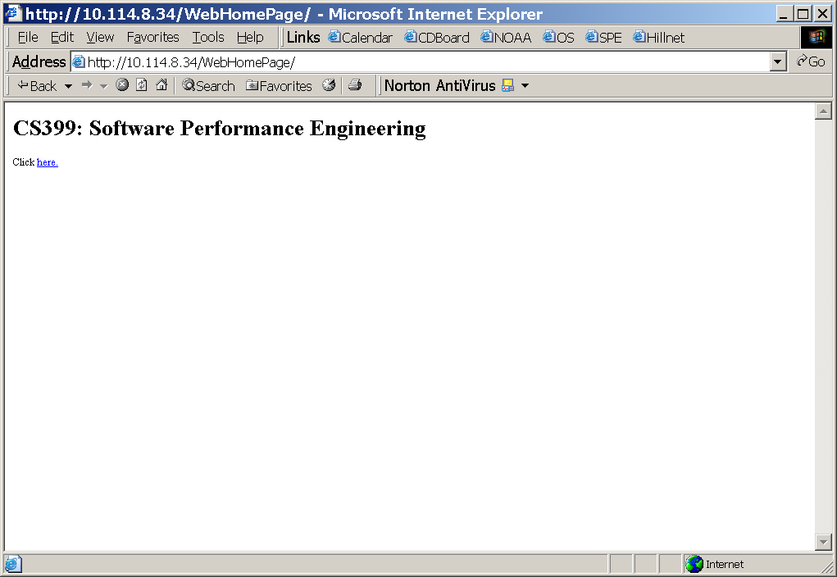
- Have the user click on the “here” link and a mockup of the Stonehill College home page will appear after a random delay between 1 and 30 seconds.

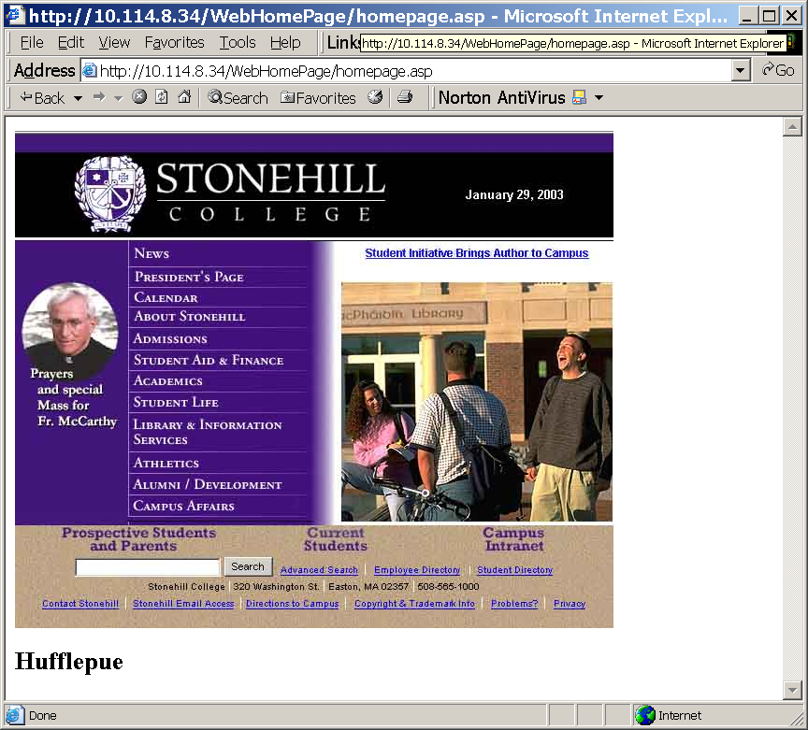

- Ask the user to rate the responsiveness of the page using the scale described in Step 2.

- At the bottom of the mockup page a code will appear. Write down the LAST LETTER of the code. In the example above the code word is “Hufflepue” and the last letter is “e”. Write down “e” next to the users’s responsiveness rating. The decoder key is:

Last Letter of Code | Web Page Delay In Seconds
y | 1
a | 2
u | 5
e | 10
o | 15
i | 30

But don’t tell the user about this key.
- Have the user click on the BACK button to return to the top level web page.

- Repeat steps 5-9 four more times for a total of FIVE samples from the user.

- When you are done you should have 50 measurements to report back. Download the excel spreadsheet located under project1 on the course website. You can use the following paper form while working with the subject.
Subject: Broadband
Code | Rating
 | 1 2 3 4 5
 | 1 2 3 4 5
 | 1 2 3 4 5
 | 1 2 3 4 5
 | 1 2 3 4 5

Subject: Broadband
Code | Rating
 | 1 2 3 4 5
 | 1 2 3 4 5
 | 1 2 3 4 5
 | 1 2 3 4 5
 | 1 2 3 4 5

Subject: Broadband
Code | Rating
 | 1 2 3 4 5
 | 1 2 3 4 5
 | 1 2 3 4 5
 | 1 2 3 4 5
 | 1 2 3 4 5

Subject: Broadband
Code | Rating
 | 1 2 3 4 5
 | 1 2 3 4 5
 | 1 2 3 4 5
 | 1 2 3 4 5
 | 1 2 3 4 5

Subject: Broadband
Code | Rating
 | 1 2 3 4 5
 | 1 2 3 4 5
 | 1 2 3 4 5
 | 1 2 3 4 5
 | 1 2 3 4 5

Subject: 56K Modem
Code | Rating
 | 1 2 3 4 5
 | 1 2 3 4 5
 | 1 2 3 4 5
 | 1 2 3 4 5
 | 1 2 3 4 5

Subject: 56K Modem
Code | Rating
 | 1 2 3 4 5
 | 1 2 3 4 5
 | 1 2 3 4 5
 | 1 2 3 4 5
 | 1 2 3 4 5

Subject: 56K Modem
Code | Rating
 | 1 2 3 4 5
 | 1 2 3 4 5
 | 1 2 3 4 5
 | 1 2 3 4 5
 | 1 2 3 4 5

Subject: 56K Modem
Code | Rating
 | 1 2 3 4 5
 | 1 2 3 4 5
 | 1 2 3 4 5
 | 1 2 3 4 5
 | 1 2 3 4 5

Subject: 56K Modem
Code | Rating
 | 1 2 3 4 5
 | 1 2 3 4 5
 | 1 2 3 4 5
 | 1 2 3 4 5
 | 1 2 3 4 5

