CS399 Mid-Term Exam
Spring 2003
March 5, 2003

Problem 1 – What is Performance?

Your manager comes into your office and tells you that the software system you are building should perform well.

- Describe in detail the three main components of performance.
- Give an example of each.

Response Time is the time it takes to process a request. More formally it is the difference between the time a request was issued and the time a response for the request is received. For example, if an http request was sent from a web browser to a web server at time t0 and a response was received at time t1, then the response time for the request would be t1-t0.

Throughput is the measurement of the number of requests a system can process per unit time. For example if a web server processes requests from web browsers, the throughput of the web server could be measured as the number of requests processed per second.

Resource Utilization is the measurement of the resources consumed when processing a request. Examples of resources include CPU, memory, disk and network. Utilization is measured over some period. This period can be either the duration of a request, or over some fixed time. For example, a web server may use the CPU 60% of the time when processing a request.

Understanding the performance of any system requires that all three of these characteristics be understood.
Problem 2 – Software Life Cycle

There are several well-known models of the software life cycle. During the course, we examined the waterfall model.

- List and briefly describe each stage of the waterfall model.
- Identify where performance awareness typically occurs in the life cycle.
- Identify where performance awareness SHOULD occur in the life cycle.
- Justify your choice for 3.

Requirements – provides a description of what the system is supposed to do; typically these requirements are produced through consultation with the user population that will utilize the system to solve some problem

Specification – describes what functions are needed to meet the requirements, but does not describe HOW those functions will be implemented

Design – describes how the functions from the specification will be implemented; usually this is done in a language neutral manner

Implementation – translates the design into a programming language to implement each of the functions

Integration – combines all of the functions together to build a complete system

Test – using specification and requirements, verifies the completed system

Release – the system is released to the user population

Maintenance – corrections are made to the system based on problems uncovered by user

Performance awareness typically occurs LATE in the testing phase of the life cycle, after the majority of bugs relating to the functionality of the system have been uncovered. For a system in which performance plays a critical role, this creates a great deal of risk because of the cost of late cycle redesign. Performance awareness SHOULD begin in the requirements phase of the software life cycle for two reasons. First, performance IS a requirement for any application. Second, the earlier a performance problem is uncovered in the life cycle the cheaper it is to correct.
Problem 3 – Performance Myths

There are THREE core myths that continue to perpetuate performance problems when new software systems are constructed.

- List the three myths.
- Explain why each myth is untrue.

Myth #1: You need something to measure before you can worry about performance

The software performance engineering methodology provides a mechanism for creating performance models which can accurately predict the performance of a system that hasn’t been built yet. These models can be used to identify and correct performance problems early on, reducing the higher cost of corrections later in the life cycle. Also, the models can be used to evaluate competing designs without the cost of implementing prototypes.

Myth #2: Managing performance takes too much time

Too much of anything is bad. Performance should be managed in a sensible fashion according to risk. The bigger the performance risk on a project, the more time should be spent managing performance. Also, by starting performance management early in the life you can detect problems earlier. Early detection and correction will save time and money in the long run.

Myth #3: Models are too complex and expensive to construct.

Performance models are actually quite simple to construct and evaluate. The models are constructed by converting performance critical use cases into UML sequence diagrams, and converting the sequence diagrams into flow-chart like software execution models. These models can be solved using a simple spreadsheet.

Problem 4 – Software Execution Modeling

Stonehill College’s Residential Life Office is responsible for administering the Merit Point Program. The Merit Point Program awards merit points to students for attending various events on campus and participating in volunteer activities. Students can also loose merit points for poor or destructive behavior (for example, damaging dormitory property). Each spring, merit points are used to prioritize who gets first pick of the dorms on campus for the following school year.

One headache is that whenever a student wants to find out her current merit point total, she has to call or visit Residential Life and an employee has to look it up on a special administrative database on campus. Students are frustrated because they don’t have twenty-four hour access to the information. Residential Life is frustrated because employee time is wasted performing this simple clerical task. To eliminate this headache a new Merit Point Web System is being developed.

The web system consists of several components displayed in the Physical UML diagram below:

There are two principle tasks that the system performs: Populate Database and View Merit Points.

Populate Database Task:

Every night, a special file representing the most up-to-date merit points for each student in a special directory is placed on the Residential Life Server. The file contains merit point information for 2000 students, with an average of 10 merit point records per student. A merit point record consists of a text string representing the reason for the record and a positive or negative integer representing the number of merit points associated with the record.

The Populate Daemon is a special process that periodically checks for this file. The process sleeps for five minutes, then wakes up and checks to see if the file has appeared in the special directory. If the process doesn’t find the file, it goes back to sleep for another five minutes.

If the process does find the file, it sends a command to the database server to delete the current merit point database, and converts each line of the file into SQL insert statements which are sent to the database server to recreate the merit point database. When the file has been completely read and inserted, a commit statement is sent to the database server, and the file is deleted. The process then starts checking for a new file again.

View Merit Point Task:

When a student wants to view her merit points for the year, she types in the URL of the Merit Point Web system on a browser. The merit point web server receives the http request from the user and determines userid automatically from cookie information sent by the browser. The web server sends a query to the database server to retrieve the merit point records for the user using this userid. The merit point records returned from the database server are formatted into html by the web server, and a merit point total is computed. This total is also formatted into html by the web server. The html produced by the web server is sent to then sent to the browser. The browser receives the html and renders it for the user to view.

Use Case Diagram for Merit Point Web System
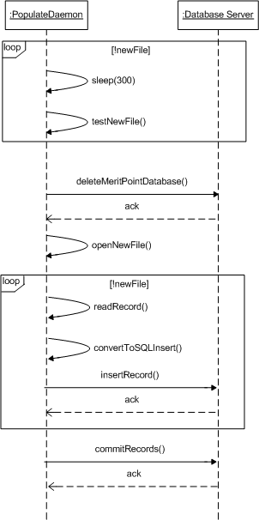
Draw a UML Sequence Diagram for the Populate Database Use Case:
Draw a UML Sequence Diagram for the View Merit Point Task Use Case:
Draw a Software Execution Model diagram using your Populate Database Sequence Diagram, next to each node list the Software Resources consumed.

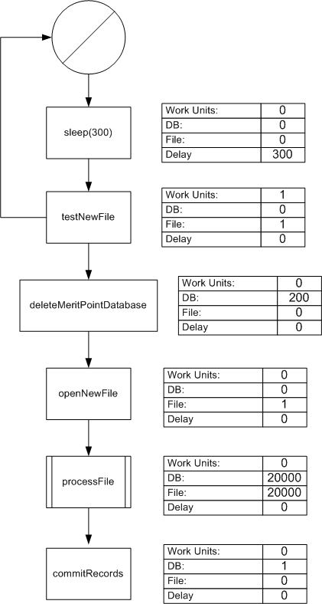
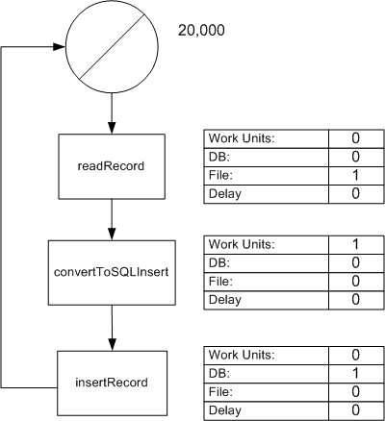
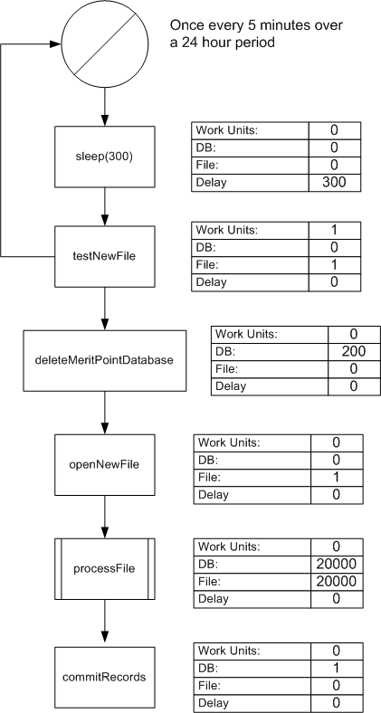
Construct a Processing Overhead Table for your Populate Database Software Execution Model:

Compute the TOTAL SERVICE TIME for the DB software resource ONLY:

Total DB software resources consumed = 20021 units.

TOTAL SERVICE TIME for DB software resource = 20021 * (service time 1 DB software resource unit)
= 20021 * (500*.00001 + 2*.02 + 1*.01)
= 1101.2 seconds

Here’s the entire software execution model:
Problem 5 – System Execution Modeling

Execution Profile for Problem 5

Using the execution profile above, determine the following:

- Measurement period, T:

T = 20 seconds

- Number of arrivals, A, into the system assuming that an arrival and departure cannot happen during the same second?

A = 8

- Number of completions, C:

C = 8

- Busy time of the system during the measurement period:

14 seconds

- Utilization, U:

U = B/T = 14/20 = .7 = 70%

- Throughput, λ:

λ = C/T = 8/20 = .4 jobs/sec

- Residence Time, RT:

RT = W (area under graph) / C = 33 job-sec / 8 job = 4.125 sec

- Queue Length, L:

L = W / T = 33 job-sec / 20 sec = 1.65 jobs

- Average Service Time, S:

S = B / C = 14 sec / 8 job = 1.75 sec/job

