Automated Ticketing System
User Manual

Version 1.0 for Windows Mobile 2003
May 12, 2005

Meganne Atkins | Mike Barucci | Andrew Harmon | Ray Powers

Table of Contents

1.0 Introduction
2.0 Installation/System Requirements
3.0 Overview of Screens
3.1 Login Screen
3.2 License Plate Query Screen
3.3 License Plate Found Screen
3.4 Known Violation Entry Screen
3.5 License Plate Not Found Screen
3.6 Enter Model Screen
3.7 Recent Tickets Screen
3.8 Ticket Overview Screen
3.9 Off-Campus Tow Screen
3.10 Signature Screen
4.0 Starting the Program/Logging In
5.0 License Plate Query
6.0 Issuing a Violation
6.1 For a Know Violator
6.2 For an Unknown Violator
7.0 Previewing Ticket Information
8.0 Viewing Recently Issued Tickets
9.0 Issuing an Off-Campus Tow
10.0 Printing a Ticket

1.0 Introduction

The Automated Ticketing System is a program that allows the user to access a database to query license plates and issue parking tickets to violators. The program runs wirelessly on a PDA, giving the user access to a database stored on a remote machine. If the vehicle in question is in violation, the user is given the choice between issuing a ticket and issuing an On-Campus Tow. Finally, the user can print the ticket, which will include all the relevant information.

The following document gives an overview of the Automated Ticketing System. Included is a detailed explanation of each screen found in the system as well as instructions for running the various components of the Automated Ticketing System

2.0 Installation/System Requirements

The Automated Ticketing System is designed to run on a Pocket PC. The application will be pre-loaded onto the Pocket PC so it will require no installation.

Microsoft Access is required to store the database because the Automated Ticketing System is designed to sync with Microsoft Access.

The Automated Ticketing System will run on most Pocket PC’s running with at least 48MB RAM and 16-bit color. The recommended system requirements for the application are given in the following list:

Microsoft® Windows® Mobile 2003 Premium for Pocket PC
Intel® XScale™ 400MHz processor
Integrated Bluetooth® with SDIO WLAN 802.11b card
64 MB RAM
25 MB of free memory (to store the database files)
Wireless Printer

3.0 Overview of Screens

The following section provides an overview and a screenshot of each screen within the Automated Ticketing System.

3.1 Login Screen

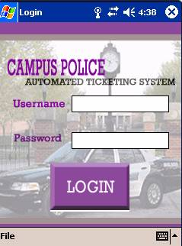
(Fig. 3.1.1 Login Screen)

This screen will be accessible when the program is first opened. This screen will enable the user to log into the Automated Ticketing System. Clicking the “Login” button will access the License Plate Query Screen.

3.2 License Plate Query Screen

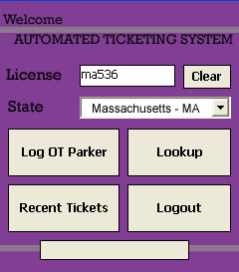

(Fig. 3.2.1 License Plate Query Screen)

This screen will be accessible from the Login Screen. This screen will enable the user to request vehicle and permit information pertaining to a specific license plate number. Clicking the “Lookup” button will access the License Plate Found Screen or the License Plate Not Found Screen. Clicking the “Log OT Parker” button will access the License Plate Query Screen. Clicking the “Recent Tickets” button will access the Recent Tickets Screen. Clicking the “Logout” button will exit the Automated Ticketing System.

3.3 License Plate Found Screen

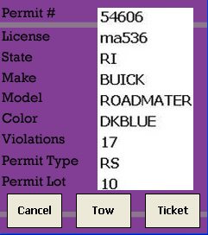

(Fig. 3.3.1 License Plate Found Screen)

This screen will be accessible from the License Plate Query Screen. This screen will provide vehicle information for the license plate entry, from the user, at the License Plate Query Screen. Clicking the “Ticket” button will access the Enter Model Screen. Clicking the “Tow” button will access the Off-Campus Tow Screen. Clicking the “Cancel” button will return to the License Plate Query Screen.

3.4 Known Violation Entry Screen

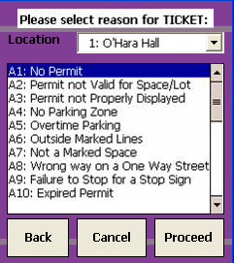

(Fig. 3.4.1 Known Violation Entry Screen)

This screen will be accessible from the License Plate Found Screen, the Unknown Violation Entry Screen, the Ticket Overview Screen and the Off-Campus Tow Screen. This screen will be part of the ticket issuing process. It will prompt the user to enter the type of violation, and possibly a lot number. Clicking the “Proceed” button will access the Ticket Overview Screen.

3.5 License Plate Not Found Screen

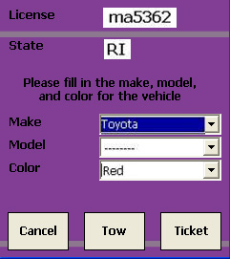

(Fig. 3.5.1 License Plate Not Found Screen)

This screen will be accessible from the License Plate Query Screen. This screen will inform the user that the license plate entered was not found within the database. This screen will enable the user to decide whether or not to issue a ticket to a car without a permit. Clicking the “Ticket” button will access the Enter Model Screen. Clicking the “Tow” button will access the Off-Campus Tow Screen. Clicking the “Cancel” button will return to the License Plate Query Screen.

3.6 Enter Make/Model/Color Screen

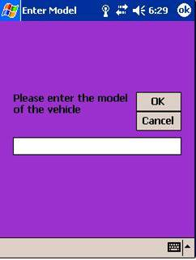

(Fig 3.6.1 Enter Make/Model/Color Screen)

This screen will be accessible from the License Plate Not Found Screen. This screen will enable the user to input additional vehicle information in order to issue tickets to vehicles not found in the parking database. Clicking the “OK” button will access the Known License Violation Entry Screen.

3.7 Recent Tickets Screen

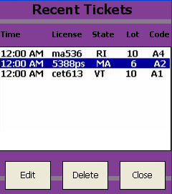

(Fig. 3.7.1 Recent Tickets Screen)

This screen will be accessible from the License Plate Query Screen. This screen will enable the user to search and access tickets that were recently written so they may be edited or deleted.

3.8 Ticket Overview Screen

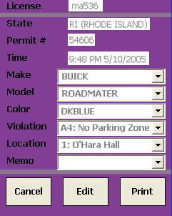

(Fig. 3.8.1 Ticket Overview Screen)

This screen will be accessible from the Known Violation Entry Screen and the Recent Tickets Screen. This screen will give the user a final view of the ticket that will be issued, and enable the user to make any final changes that may be necessary before printing the ticket. Clicking the “Print” button will take the user to the Signature Screen.

3.9 Off-Campus Tow Screen

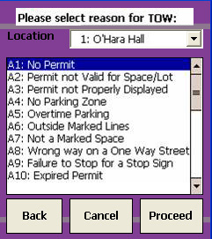

(Fig. 3.9.1 Off-Campus Tow Screen)

This screen will be accessible from the License Plate Not Found Screen and the License Plate Found Screen. This screen will inform the user if the license plate appears on the tow list or not. Clicking the “Proceed” button will access the Known Violation Screen.

3.10 Signature Screen

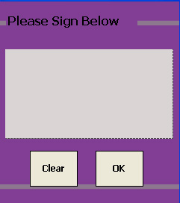

(Fig. 3.10.1 Signature Screen)

This screen will be accessible from the Ticket Overview Screen. This screen will allow the user to write a signature using the Stylus Pen. Clicking the “OK” button will print the ticket. Clicking the “Clear” button will erase the signature.

4.0 Starting the Program/ Logging In

To begin, turn on the PDA. Consult the PDA user manual for detailed instructions on operating the device.

Once the PDA is running, you will need to start the Automated Ticketing System. The following steps will guide you through the process of locating and starting the program. Note: these steps may be slightly different depending on the setup of your PDA.

To Being the Automated Ticketing System:

- Click on the Windows Logo at the top left hand side of the screen.

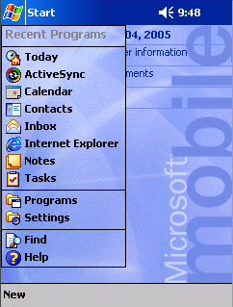
(Fig. 4.0.1 Start Menu)

- Under the Start menu, select “Programs.”
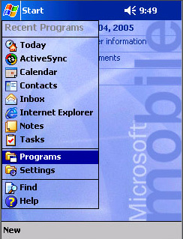
(Fig. 4.0.2 Programs Menu)
- You will now see a series of icons. Click on the Automated Ticketing System icon to launch the program.

To begin using the program, you will be required to login. The Log-in Screen applies security to the database. Before being allowed to query the database, you must log on using your unique username and password.

To Log In:

- Using the digital keyboard on the PDA, enter your username into the “Username” field followed by your password in the “Password” field.
- Click on the “Login” button.
(Fig. 4.0.3 Login Screen)
Enter your username and password using the digital keyboard
- If the username and password are valid, you will be taken to the License Plate Query Screen
- If the username and password are invalid, an error message will appear and you will need to re-enter your username and password.

5.0 License Plate Query

The License Plate Query Screen acts as a main menu to navigate through the ticketing system. You will have the option of querying a vehicle in the database, logging an overtime parker, or logging out of the system.

To Query a license plate:

- Using the digital keyboard on the PDA, enter the license plate you wish to query into the “License Plate” field.
- Choose the appropriate state of the license plate from the drop-down menu.
- Click on the “Lookup” button to query the database for the license plate.

(Fig. 5.0.1 License Plate Query Screen)

Enter the License Plate using the digital keyboard then select the state from the drop-down menu. Click on “Lookup” when you are done.
- If the license plate is found in the database, you will be sent to the License Plate Found Screen. If the license plate is not found in the database, you will be sent to the License Plate Not Found Screen.

When a license plate is found, you will be sent to the License Plate Found Screen. From this screen you will be able to issue a ticket (on the Known Violation Screen) or issue an on-campus tow from the On-Campus Tow Screen.

When a license plate is not found, you will be sent to the License Plate Not Found Screen. From this screen you will be able to issue a ticket (on the Unknown Violation Screen) or issue an on-campus tow from the On-Campus Tow Screen.

If you want to Log an Overtime Parker, click on the “Log OT Parker” Button. If the vehicle has not been logged at a start time, the following message will appear, “This vehicle with has been logged in the overtime parking list.” The vehicle information and the current time will be stored.

If you click on the “Log OT Parker” button and the vehicle has previously been logged for OT parking, you will get one of two messages.
- If the vehicle has exceeded the 20 minute time limit, you will receive the following message, “This vehicle has been parked for 21 minutes. Would you like to issue a ticket?" From here you will be given the option to issue a ticket or continue without issuing a ticket.
- If the vehicle has not yet exceeded the 20 minute time limit, you will receive the following message, “This vehicle has not yet exceeded the time limit.", "Vehicle not in violation.”

The following sections give a detailed explanation on issuing tickets and on-campus tow’s.

6.0 Issuing a Violation

There are two types of violations that can be issued. If a license plate is found, you will be issuing a violation for a known violator. If the license plate is not found, you will be issuing a violation for an unknown violator. Known violators have their information stored in the database. Unknown violators do not have information stored in the database.

When issuing a ticket for a known violator, you will not need to enter vehicle information. Based on the license plate entered, the information will automatically be added to the ticket.

When issuing a ticket for an unknown violator, you will be required to enter vehicle information.

Sections 6.1 and 6.2 below describe the process of issuing a violation to known and unknown violators.

6.1 For a Know Violator

After you have entered a license plate number and state and it has been found in the database, you will be sent to the License Plate Found Screen. This screen will display vehicle and permit information based on the license plate query. You will be required to issue a Ticket, issue an Off-Campus Tow or return to the License Plate Query Screen based on the location of the vehicle and the permit/vehicle information

To return to the License Plate Query Screen, click on the button labeled “Cancel.”

To issue a ticket (to a known violator):
- On the License Plate Found Screen, click on the button labeled “Ticket.” From here you will be sent to the Known Violation Screen. Note: All vehicle and permit information is saved for the ticketing process.

(Fig. 6.1.1 License Plate Found Screen)

Click on the “Ticket” button to issue a ticket

- On the Known Violation Screen, you need to enter the type of violation and the lot number where the violation has taken place. Select the violation type from the “Violation” menu list. Select the lot number from the “Location” drop-down box.

(Fig. 6.1.2 Known Violation Screen)

Select the appropriate Lot Number and Violation Type

- Once you have selected the appropriate information, click on the “Proceed” button. You will be sent to the Ticket Overview Screen to preview the ticket being issued.
- If you believe you have made an error in the information or wish to start over, click the “Cancel” button. You will be sent back to the License Plate Query Screen. If you wish to go back to the previous screen, click on the “Back” button. Note: all data entered for the ticket will be deleted when you click on the “Cancel” button and return to the License Plate Query Screen.

6.2 For an Unknown Violator

After you have entered a license plate number and state and it has not been found in the database, you will be sent to the License Plate Not Found Screen. From this screen you will be required to issue a ticket, issue an Off-Campus Tow or return to the License Plate Query Screen.

To return to the License Plate Query Screen, click on the button labeled “Return to Query.”

To issue a ticket (to an unknown violator):
- On the License Plate Not Found Screen, select the Make of the car from the “Make” drop-down box. Select the Model from the “Model” drop-down box. Select the Color from the “Color” drop-down box. Click on the button labeled “Ticket.” If you select “other in any of the drop-down boxes, you will be sent to the Enter Make/Model/Color Screen.

(Fig. 6.2.1 License Plate Not Found Screen)

Select “Make” “Model” and “Color” of the vehicle and click “Ticket”

- If you select “other”, you will be required to enter the Make/Model/Color of the vehicle using the digital keyboard on the PDA. Type the make/model/color of the vehicle then click on the “OK” button to continue.

(Fig. 6.2.2 Enter Make/Model/Color Screen)

Enter the Model of the vehicle and click “OK”

- You will be taken to the Known Violation Entry Screen where you need to enter the type of violation and the lot number where the violation has taken place. Select the violation type from the “Violation” menu list. Select the lot number from the “Location” drop-down box.

(Fig. 6.1.2 Known Violation Screen)

Select the appropriate Lot Number and Violation Type

- Once you have selected the appropriate information, click on the “Proceed” button. You will be sent to the Ticket Overview Screen to preview the ticket being issued.
- If you believe you have made an error in the information or wish to start over, click the “Cancel” button. You will be sent back to the License Plate Query Screen. If you wish to go back to the previous screen, click on the “Back” button. Note: all data entered for the ticket will be deleted when you click on the “Cancel” button and return to the License Plate Query Screen.

7.0 Previewing Ticket Information

Once you have entered the appropriate information for a violation, you will be sent to the Ticket Overview Screen. From this screen you will have the option to either request to change the information on the ticket, print the ticket, or return to one of the violation entry screens.

To change the information on the ticket:
- Each field on the ticket will allow you to change the data located in that field.
- If you wish to change the vehicle make, vehicle color, vehicle model, violation type, or lot number, click on the “Edit” button. Now you can click on the appropriate text in the text box, delete it, and enter the correct information. For example, if you entered “blue” as the vehicle color and wish to change it to “green,” select “green” from the “Color” drop-down box.

(Fig. 7.0.1 Ticket Overview Screen)

You can make changes to the ticket information before it is printed.

- You may change any of the information on the Ticket Overview Screen as many times as you like. When you are satisfied with the information on the ticket, press the “Print” button.
- If you want to start over, click on the “Cancel” button. You will be sent back to the License Plate Query Screen. Note: all data entered will be lost.

Clicking on the “Print” button will print the ticket, with the data shown on the Ticket Overview Screen. In order to print the ticket, you will be required to have the Brother MW-100/120/140BT printer connected (wirelessly) to the PDA. See the Brother MW-100/120/140BT printer user manual for more information on connecting the printer to the PDA.

When you click the “Print” button, you will be taken to the Signature Screen. From here you will use the Stylus pen to write you signature. Your signature will be placed on the ticket for authenticity.

(Fig. 7.0.2 Signature Screen)

Sign the ticket using the Stylus Pen. Your signature will appear on the ticket.

From the Ticket Overview Screen, if you wish to start over, click on the “Back to Query Screen” button. You will be sent to the License Plate Query Screen. All information entered in the previous screens will be lost.

8.0 Viewing Recently Issued Tickets

From the License Plate Query Screen, you have the option of viewing recently issued tickets. From the Recent Tickets Screen you will have the option of modifying or deleting any recently issued tickets. The Recent Tickets Screen will display the last twenty tickets processed on the PDA.

(Fig. 8.0.1 Ticket Overview Screen)

You can edit or delete previously issued tickets by selecting the appropriate button.

To Edit a recently issued ticket:
- Highlight the ticket you wish to edit.
- Click on the “Edit” button. You will be sent to the Ticket Overview Screen. From here you can edit the information on the ticket. For more information on the Ticket Overview Screen and editing ticket information, view Section 7.0.

To Delete a recently issued ticket:
- Highlight the ticket you wish to delete.
- Click on the “Delete” button.
- The selected ticket will then be deleted locally from the database stored on the PDA.

Note: Once you delete a ticket, you will not be able to get it back.

You may also return to the License Plate Query Screen by selecting the “Cancel” button on the Recent Tickets Screen.

9.0 Issuing an Off-Campus Tow

From either the License Plate Found Screen or the License Plate Not Found Screen, you will have the option to issue an off-campus tow.

To issue and off-campus tow:
- From either the License Plate Found Screen or the License Plate Not Found Screen, click on the “Tow” button.

(Fig. 9.0.1 License Plate Found Screen)

Click on the “Tow” button to issue and Off-Campus Tow.

- You will be sent to the Off-Campus Tow Screen. On this screen you will be required to enter the lot number and the reason for the on-campus tow. Select the lot number from the “Location” drop-down box. Select the reason for the tow from the “Violation” menu.

(Fig. 9.0.2 Off-Campus Tow Screen)

Select the Location and the reason for the Tow and click “Proceed”.

- Once you have entered the information, click on the “Proceed” button. The information you have entered will be stored in the database and you will be sent back to the License Plate Query Screen.

10.0 Printing a Ticket

Printing a ticket requires you to have a compatible printer connected to the PDA. A recommended printer for the Automated Ticketing System is the Brother MW-100/120/140BT printer.

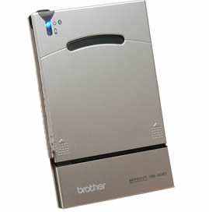
(Fig. 10.0.1 Brother MW-140 Bluetooth Printer

For more information on connecting the printer to the PDA, consult the printer’s user manual.

Note: The actual ticket that is printed will look different than the one on the Ticket Overview Screen. Additional information will be added to the ticket and re-arranged before the ticket is printed.

