Learning more about Oracle

To learn more about how to use Oracle, you can use Oracle’s extensive online documentation. This documentation is available by starting Oracle’s documentation system from the “Start” bar:

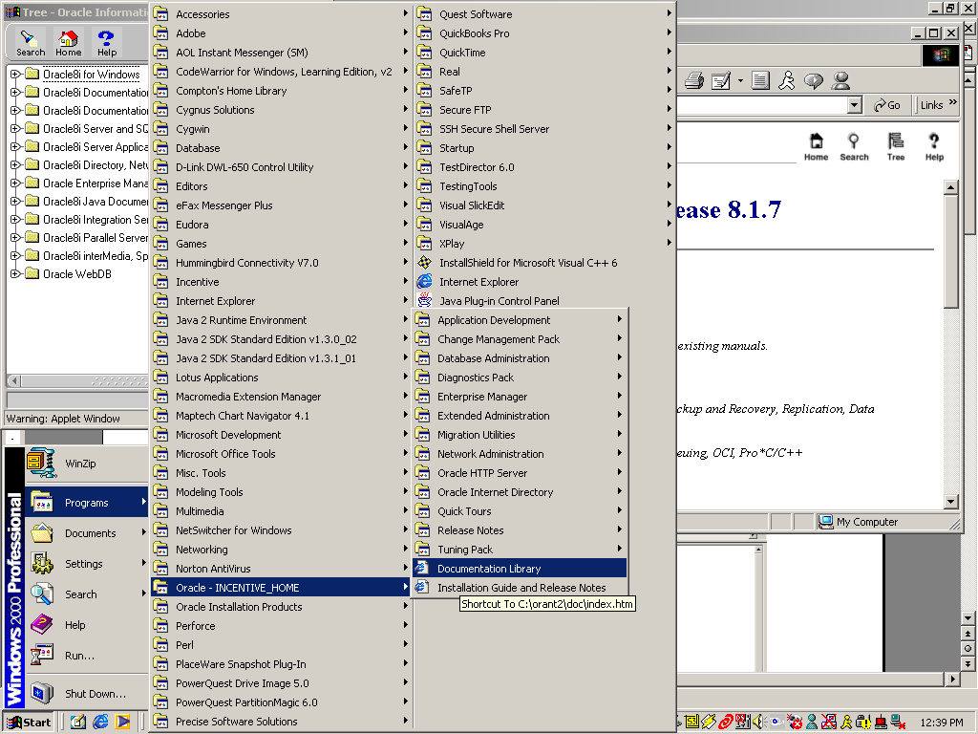

Probably the most helpful documentation is the SQL Reference which you can find under the “Oracle 8i Server and SQL*PLUS” document link:

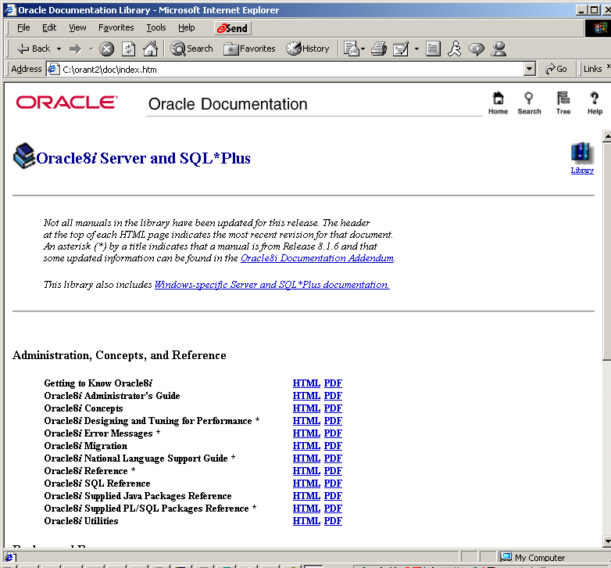

In addition to this electronic documentation, there are also several books on Oracle on reserve at the MacPhaidin library.

