How to Use DBA Studio

Step One: Start Oracle’s DBA Studio
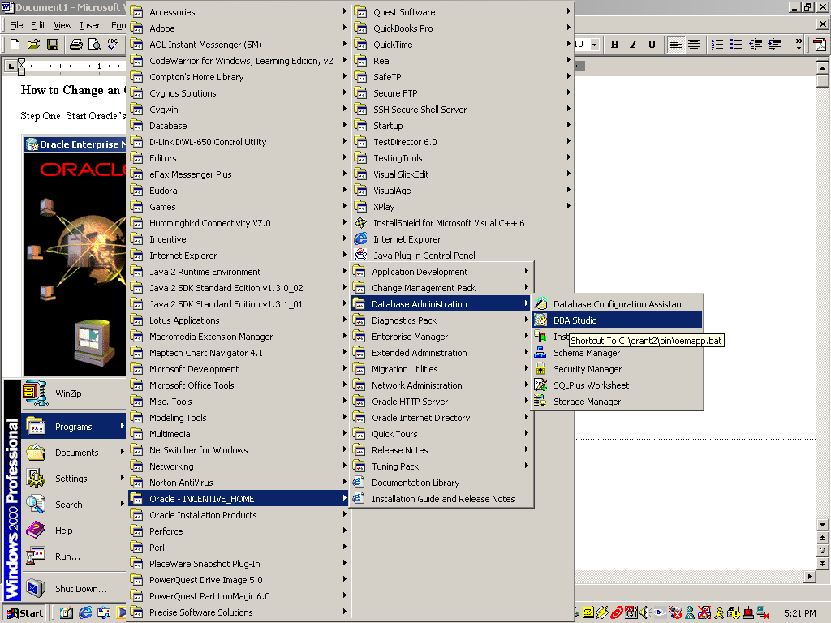

Step Two: Select Launch DBA Studio standalone

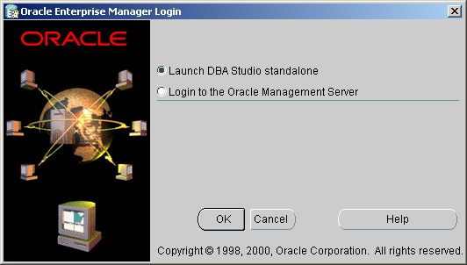

Step Three: Add the CS325 database (if it’s not there already) to DBA Studio’s List:

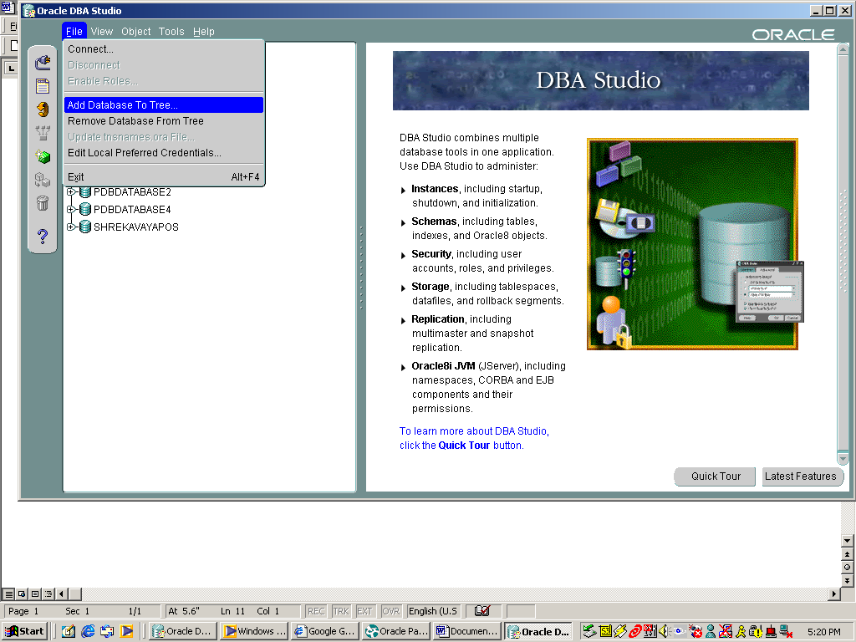

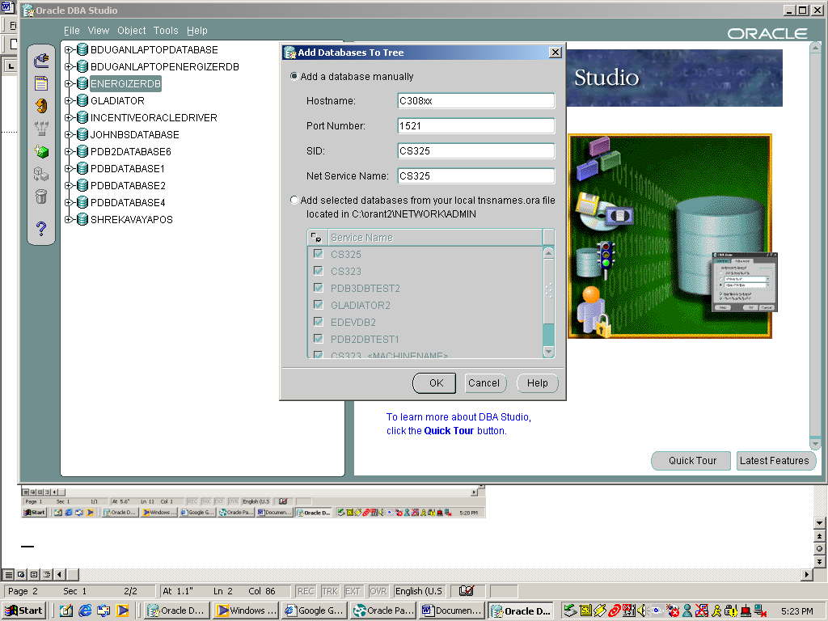

Step Four: Right-click on the CS325 Database to connect

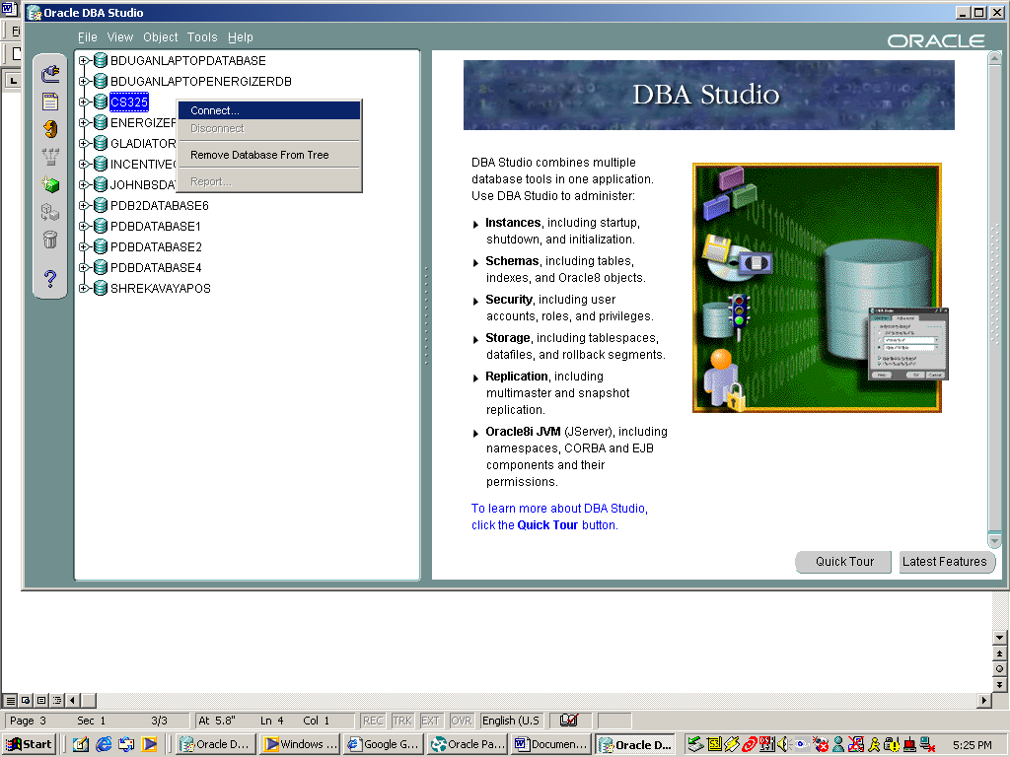

Step Five: Use username/password of system/manager:

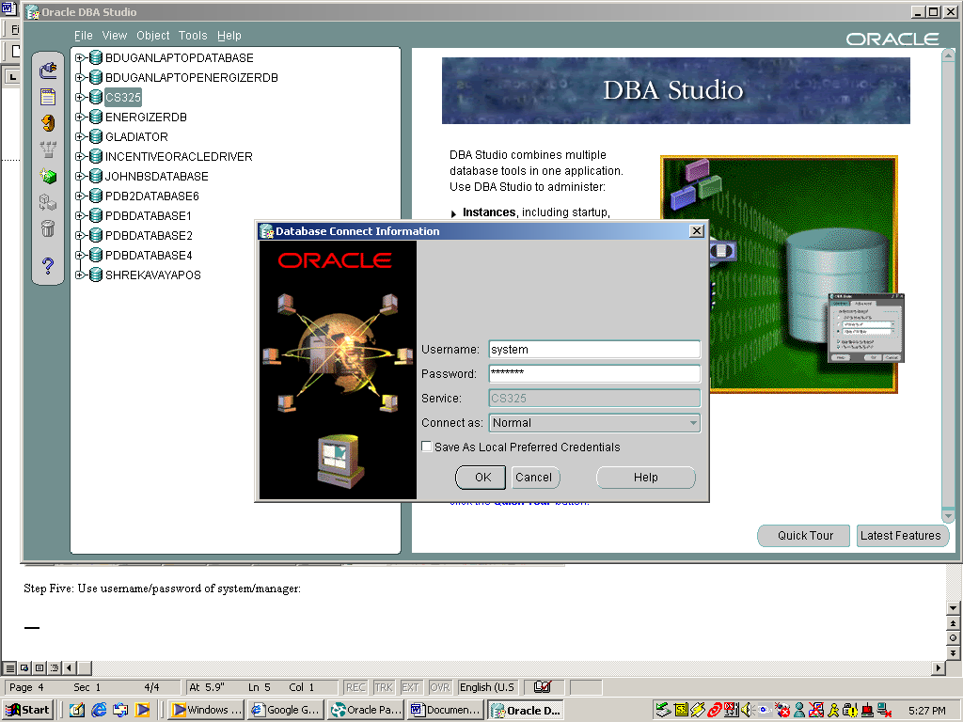

Step Six: Expand the Security->Users and Select a User

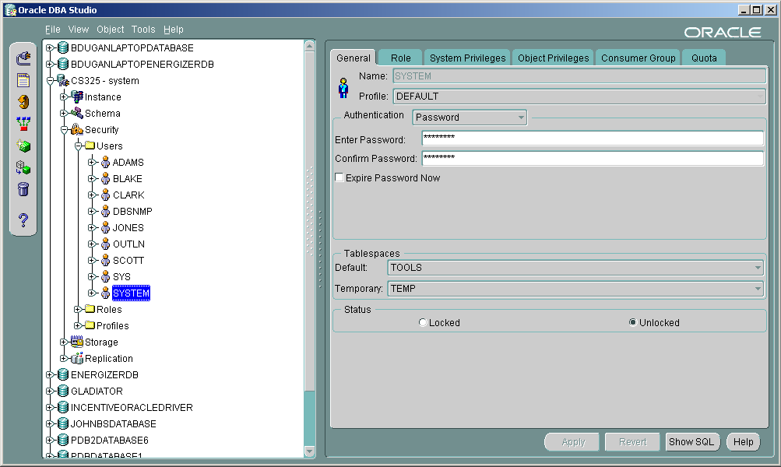

Step Seven: Type the password in after Enter Password and Confirm Password the press APPLY

