How to Connect to an Oracle Database Using SQL*Plus

Get a DOS command prompt

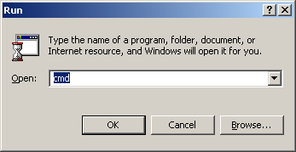

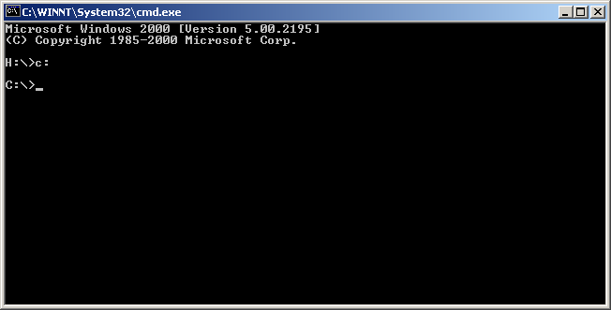

Type the following command: sqlplus <username>/<password>@ORACLE_SID

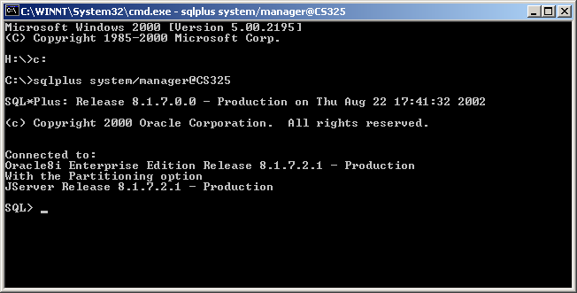

Select all rows from the schema SCOTT’s DEPT table:

