How to Export an Oracle Database

It’s important that you periodically export your Oracle database so that you don’t lose your work during the semester. This document describes how to do it.

Step 1: Execute the CATALOG.SQL Script

This script is ONLY EXECTUED ONCE. After executing the script once, you will then be able to export as often as you want.

Get a DOS command prompt.

Go to the following directory:

cd c:\oracle\ora81\rdbms\admin

Get into sqlplus using the “SYS” user:

sqlplus sys/change_on_install@cs325

Execute the catalog.sql database script:

- @catalog.sql

Wait for about 5 minutes for the script to complete.

Step 2: Run the export command pressing enter at each prompt to select defaults.

Note the userid/password I’m providing in this example may not be the userid and password you want to use:

exp scott/tiger@cs325
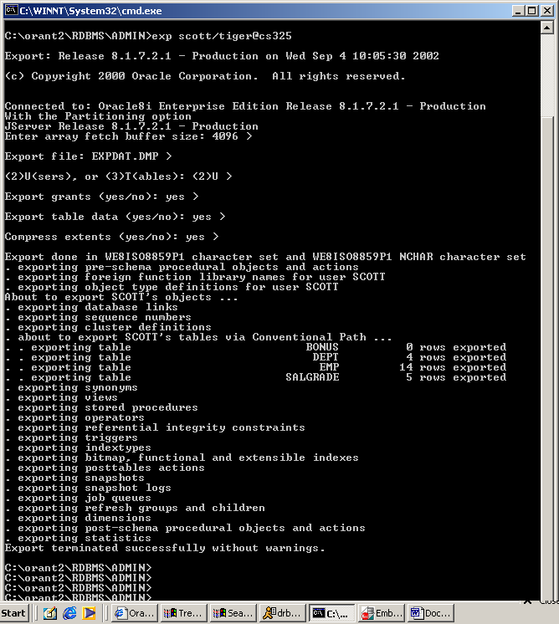

You should verify at the end of the export that the tables YOU created for your project are actually being exported by observing the “exporting table” information that appears in the export log. In this example, there were four tables exported: BONUS, DEPT, EMP, and SALGRADE.

How to Import an Oracle Database

Step 1: Execute the CATALOG.SQL Script on the database you are going to import to.

For more information on this see the previous section “How to export an Oracle Database”.

Step2: Run the import command pressing enter at each prompt to select defaults.

There is one tricky part here… when you are prompted for the “username” make sure you enter the database userid you gave to the import command. In this example the username is “scott”.

Note the userid/password I’m providing in this example may not be the userid and password you want to use:

imp scott/tiger@cs325

