Homework Six

CS325 Database Management Systems

Problem One:
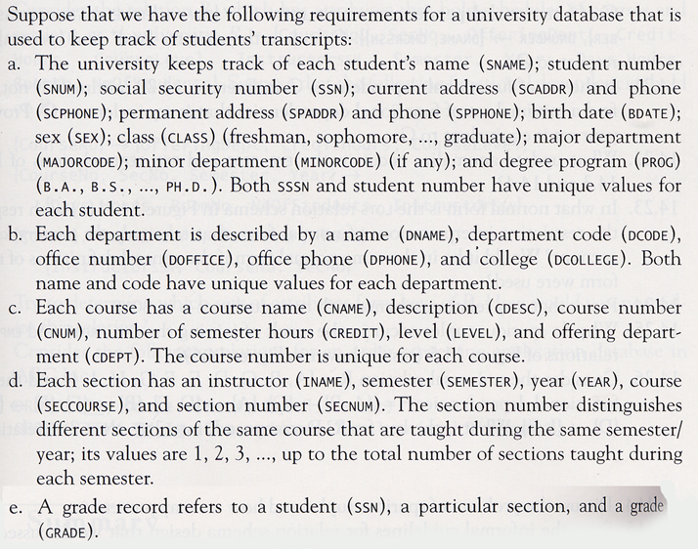
Design a relational database schema for this database application. Show primary key, candidate keys, all functional dependencies, and all attribute types. Endure that the relations are in third normal form.

Problem Two:

Prove the following using rules of inference. If it is not possible to prove, then give a counterexample.

Example: {W → Y, X → Z} ⇒ {WX → Y}

{W → Y} given
{WX → YX} augmentation rule
{YX → Y} decomposition rule
{WX → Y} transitive rule

- {X → Y, X → W, WY → Z} ⇒ {X → Z}

- {X → Z, Y → Z} ⇒ {X → Y}

- {X → Y, Z → W} ⇒ {XZ → YW}

- {X → Y, Y → Z} ⇒ {X → YZ}

Grading Criteria: 20 points with 5 points per problem.
Problem Three:

Consider the relation R = {A, B, C, D, E, F, G, H, I, J}

And the following functional dependencies:

{A,B} -> {C}
{A} -> {D,E}
{B} -> {F}
{F} -> {G,H}
{D} -> {I,J}

- What is the key for R?

- Decompose R into 2NF.

- Decompose R into 3NF.

Grading Criteria:

Maximum is 15 points broken down as follows:

Primary Key for Universal Relation 5 points
Second Normal Form 5 points
Third Normal Form: 5 points
Problem Four (Team Problem):

Construct a Relational Model for your Final Project. Ensure your Model is in 3NF.

For each relation, specify syntactically correct SQL DDL.

Prove this DDL is correct by executing it to create an ORACLE database.

The names of your tables and attributes should be unambiguous and meaningful.

Have one member of your group hand in the following:
- A copy of the Relational Model,
- SQL DDL to create your database
- Output from DESCRIBE <TABLE> command executed in ORACLE for each of your tables.

