Assignment Four

Problem One:
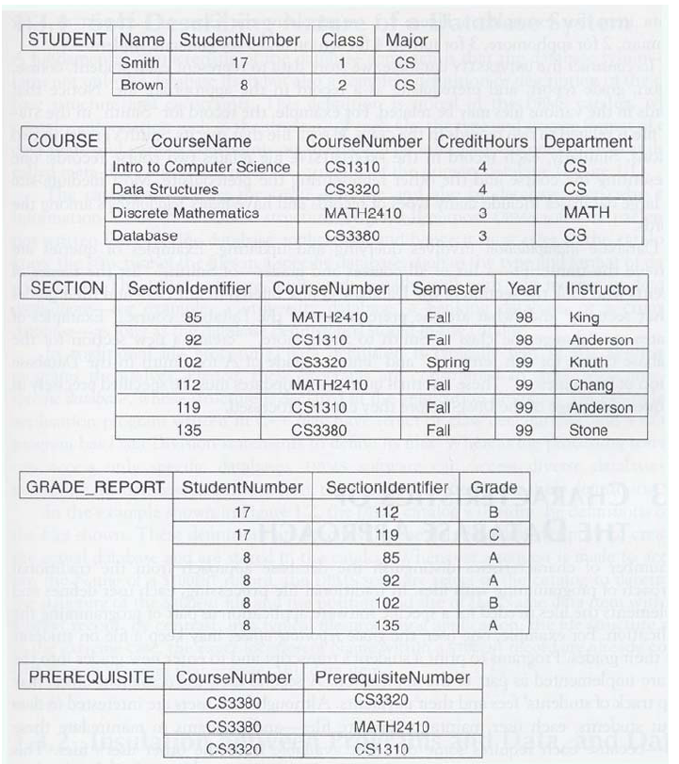
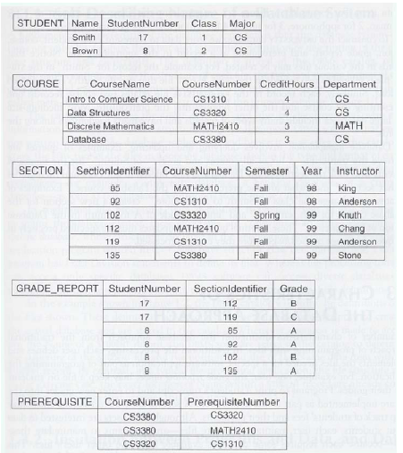
Consider the database shown above.

Identify the primary key and foreign keys in each relation.

Write appropriate SQL DDL statements to define the database. Don’t forget to describe primary and foreign keys in your relations!

Grading Criteria:

Each sub-problem received a maximum of 4 points. Maximum grade for problem was 20 points.

Basic DDL: One point off for each incorrect notation 3 points
Constraints: Correct constraints for each relation 1 point

Problem Two:

Consider the following relational schema:

Consider the following relational database:
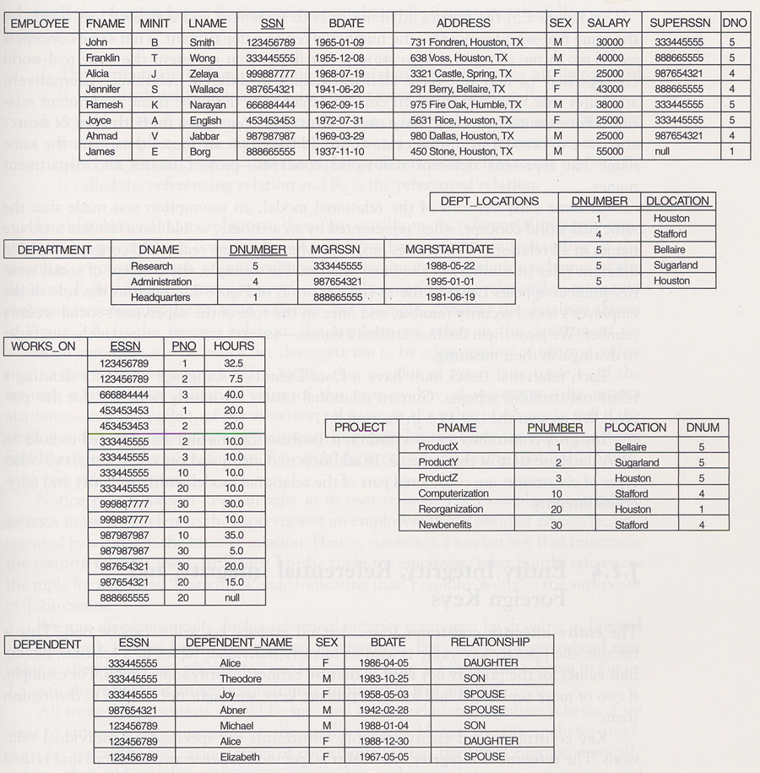

Specify the following queries on the relational schema shown above using SQL DML. Also show the result of each
query as it would apply to the database shown above.

- Retrieve the names of all employees in Department 5 who work more than 10 hours per week on the ‘ProductX’ project.

b) List the names of all employees who have a dependent with the same first name as themselves.

- Find the names of all employees who are directly supervised by ‘Franklin Wong’

d) For each project, list the project name and the total hours per week (by all employees) spent on that project.

e) For each department, retrieve the department name and the average salary of all employees working in that
department.

- Retrieve the name of employees who work on EVERY project.

- Retrieve the average salary of all female employees.

- Find the names and addresses of all employees who work on at least one project located in Houston, but whose department has no location in Houston.

- List the last names of all department managers who have no dependents.

- Who are the slackers? What are the first and last names of employees who don’t work on any project?

Grading Criteria:

Each sub-problem received a maximum of 5 points. Maximum grade for problem was 50 points. Each problem was graded differently with the cost of an error weighted by the underlying principle of the problem.

Grading Criteria:

Each sub-problem received a maximum of 5 points. Maximum grade for problem was 25 points. Each problem was graded differently with the cost of an error weighted by the underlying principle of the problem.

Problem Three (Team Problem):

Construct an Entity Relationship Diagram for your Final Project.

You MUST USE some form of electronic drawing tool for this diagram.

There are many tools available in Stanger 308 and in the Computer Science Library on the first floor. These tools
include Powerpoint, Visio, and Paint.

Your diagram should be clean and clear. I don’t want to see lines crossing other lines if at all possible.

The names of your entities, relationships, and attributes should be unambiguous and meaningful.

Have one member of your group print out a copy of your diagram and hand it in to me with your homework.

