Assignment 3

CS325 Database Management Systems

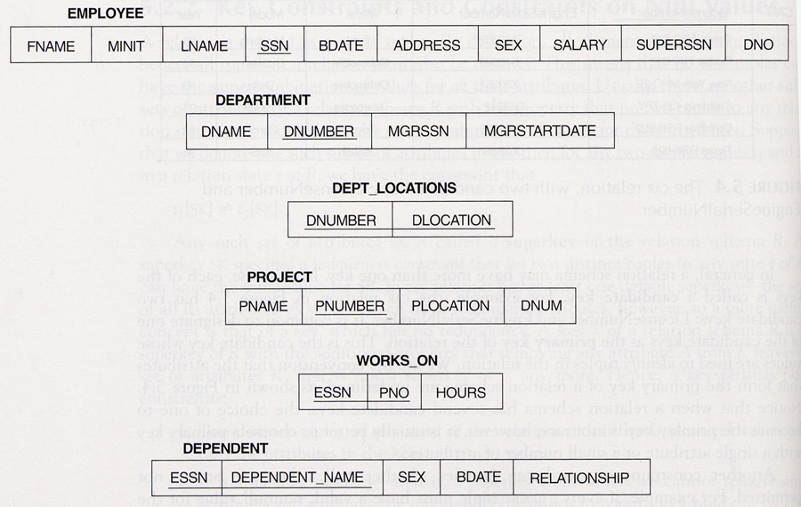
Consider the following relational schema:

Consider the following relational database:

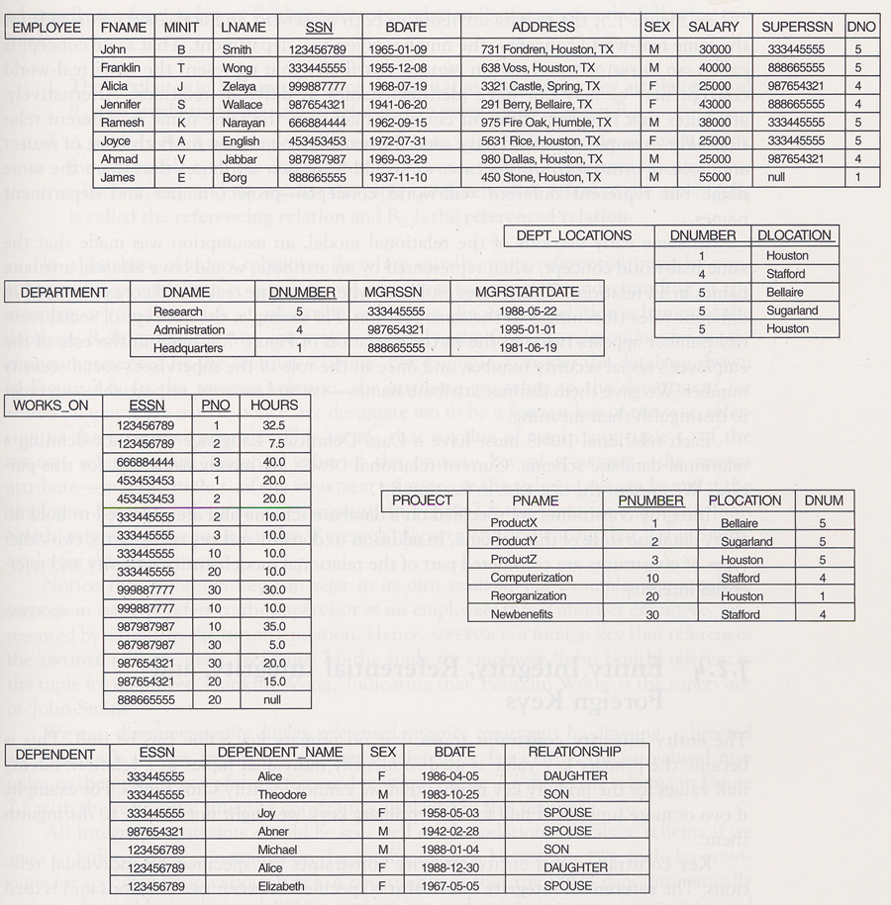

Specify the following queries on the relational schema shown above using the relational operators we discussed in class. Also show the result of each query as it would apply to the database shown above.

- Retrieve the names of all employees in Department 5 who work more than 10 hours per week on the ‘Product X’ project.

b) List the names of all employees who have a dependent with the same first name as themselves.

c) Find the names of all employees who are directly supervised by ‘Franklin Wong’.

- For each project, list the project name and the total hours per week (by all employees) spent on that project.

- For each department, retrieve the department name and the average salary of all employees working in that department.

- Retrieve the name of employees who work on EVERY project.

- Retrieve the average salary of all female employees.

- Find the names and addresses of all employees who work on at least one project located in Houston, but whose department has no location in Houston.

- List the last names of all department managers who have no dependents.

Grading Criteria:

Each problem receives a maximum of 4 points. Maximum grade for homework is 36 points.

Relational Algebra: One point off for each incorrect notation 3 points
Relation: Any error in resulting relation lost the point 1 point

