Assignment 2

CS325 Database Management Systems

Problem One:
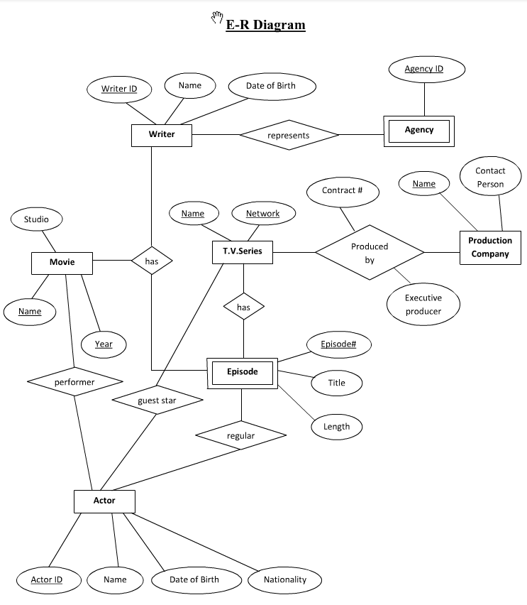

Convert the ER Diagram above into a Relational Model. (1) label the relationship constraints between the entities, (2) do the conversion, (3) underline the primary keys in each relation, (4) list the domain for each attribute.

Problem Two:

Problem Two:

Convert the ER Diagram above into a Relational Model: (1) do the conversion, (2) underline the primary keys in each relation, (3) list the domain for each attribute.

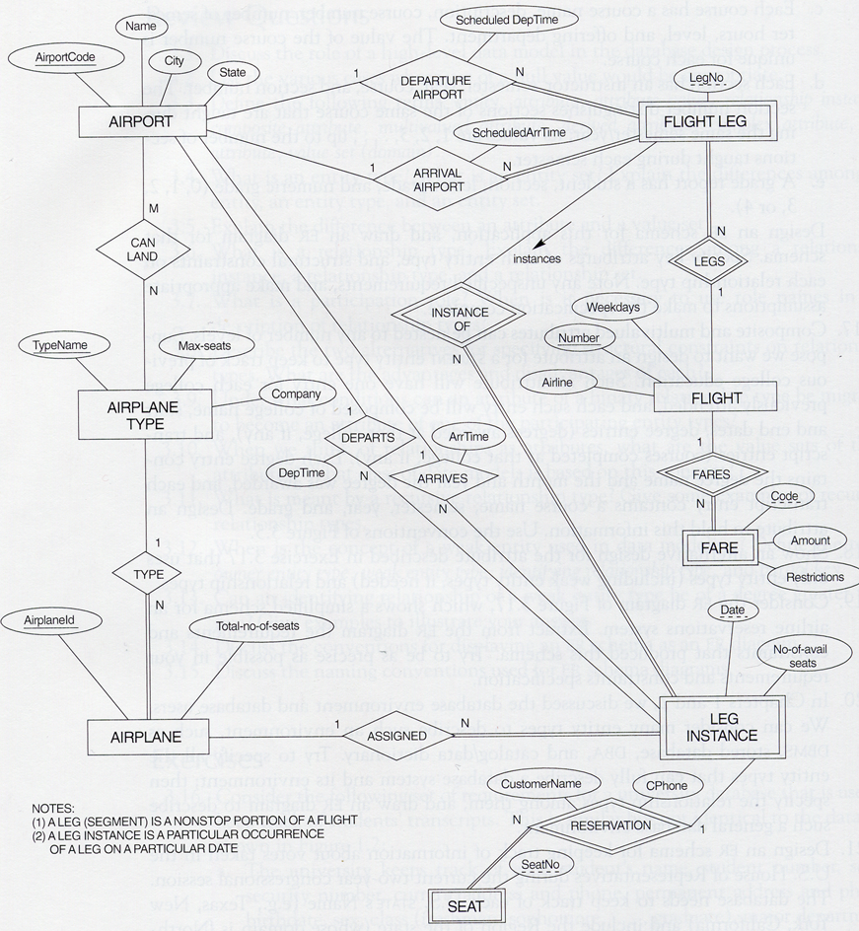
Problem Three:

Convert the ER Diagram above into a Relational Model: (1) do the conversion, (2) underline the primary keys in each relation, (3) list the domain for each attribute.

Problem Four (Team Problem):

Show me a mock up of the user interface for your team’s project. You can do this by answering the question:

What are the various screens/forms that a user will see as s/he uses your system?

Get your group together in front of a whiteboard or a large piece of paper and create a series of sketches that depict the screens/forms that will appear in your application. This is called a STORYBOARD and is very similar to the storyboards that are used to sketch out scenes in a movie.

When you are happy with your storyboard:
- Convert the storyboard into electronic form (e.g. scan your sketches, use a drawing program like PowerPoint or Visio to mock up each screen, etc.)
- Label and annotate each screen if necessary
- Show how each screen is connected the other screen

Here’s an example of a character based screen for an auction application (you can do much better than this if you plan on using a GUI):

Here’s a diagram that shows how each screen in the application is connected:

