Assignment 1

CS325 Database Management Systems

Problem One:

Create an entity relationship diagram for a chain of automobile workshops. We are interested in:

- the workshops, with name (identifying), address and telephone number
- the automobiles, with registration number (identifying), model, and owner
- the owners, with ss#, surname, first name, and telephone; each owner can own more than one vehicle
- the maintenance work carried out in a workshop, with workshop, start date, end date, parts replaced (with quantities of each part replaced), and hours of labor
- the parts with code, name, and unit cost.

(Database Systems: Concepts, Languages, and Architectures, Atzeni, Ceri, Paraboschi, Torlone, ISBN 0-07-235952-8)

To get full credit: (1) create diagram and in addition (2) list, describe, and describe the cardinatlity for each relationaship, (3) list each attribute and describe the domain of the attribute

Problem Two:
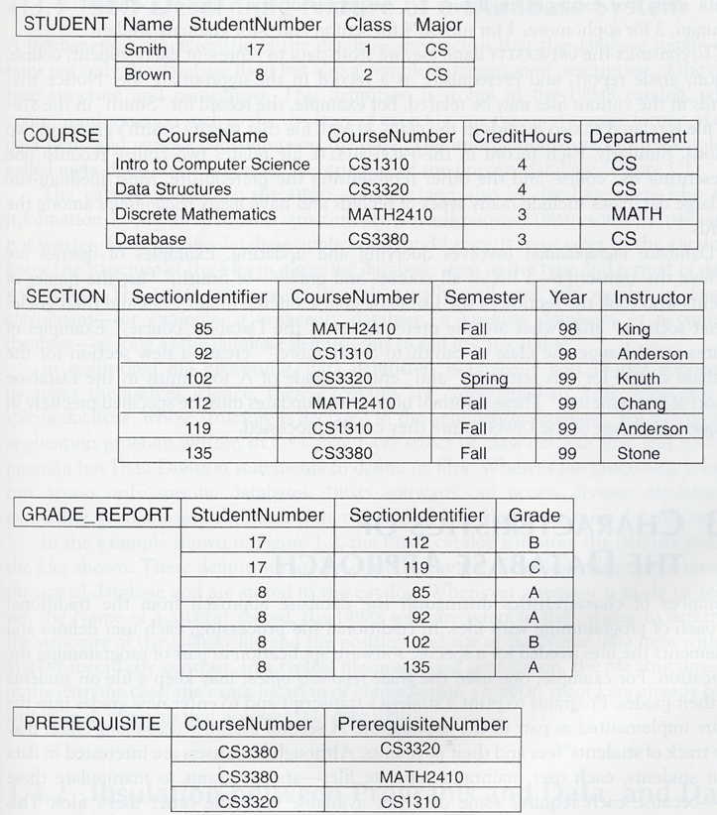

Consider the following set of requirements for a university database that is used to keep track of students’ transcripts. This is similar but not identical to the database shown in the figure above.

- The university keeps track of each student’s name, student nubmer, social security number, current address and phone, permanent address and phone, birthdate, sex, class (freshman, sophomore, ..., graduate), major department minor department (if any), and degree program (B.A., B.S., ..., Ph.D.). Some user applications need to refere to the city, state and zip code of the students permanent address and to the student’s last name. Both social security number and student number have unique values for each student.
- Each department is described by a name, department code, office number, office phone, and college. Both name and code have unique values for each department.
- Each course has a course name, description, course number, number of semester hours, level, and offering department. The value of the course number is unique fore each course.
- Each section ahs an instructor, semester, year, course, and section number. The section number distinguishes sections of the same course that are taught during the same semester year; its values are 1,2,3,..., up to the number of sections taught during each semester.
- A grade report has a student, section, letter grade, and numeric grade ((0,1,2,3 or 4).

Design an ER schema for this application, and draw an ER diagram for that schema. Specify key attributes for each entity type, and structural constraints on each relationship type. Note any unspecified requirements, and make appropriate assumptions to make the specification complete.

To get full credit: (1) create diagram and in addition (2) list, describe, and describe the cardinatlity for each relationaship, (3) list each attribute and describe the domain of the attribute

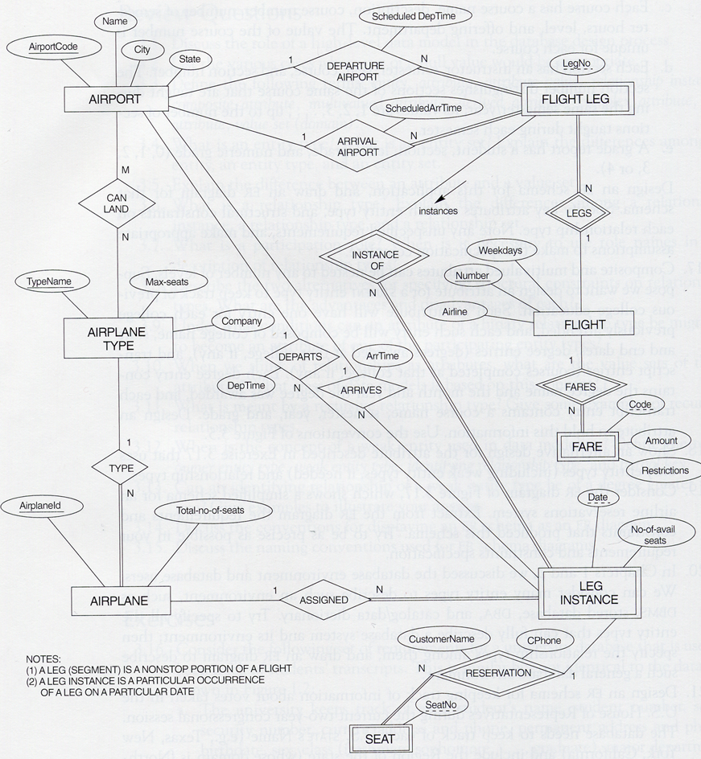
Problem Three:

This diagram shows a simplified schema for an airline reservations system. Extract from the ER diagram the requirements and constraints that produced this schema. This problem is an exercise in reverse engineering an ER Diagram. If you showed this diagram to a group of non-technical people, how would you describe what it means? If you read your answer to this problem, would you be able to recreate the ER Diagram?

Requirements describe the entities, attributes, and relationships between entities.
Constraints describe attribute domains and relationship cardinalities.

Problem Four (one solution per team):

- What is the name of your team?
- Provide a description (less than one page) of the system you’ll be building for your final project.

This description should focus on the REQUIREMENTS and GOALS of the system.... in other words WHAT the system will do. For example, the library system has two principle users: librarian and patron. Each user has a different kind of user interface. The librarian has an administrative panel allows the books to be added/removed from the inventory, ... etc.

The description should not discuss HOW the system will meet these requirements. For example, don’t say “we will use the Java mapset collection to maintain a local cache of a patron’s books”.

I’ll use this description to help ensure your team isn’t taking on too much or too little for the final project.

