Revamping Department Website

CSC324 Advanced Programming

You should rebuild the Department of Computer Science web pages using HTML and CSS. You CANNOT use a WYSIWYG editor like FrontPage, Homesite, or Dreamweaver to rebuild these pages... you have to use a simple text editor.

You should rebuild the computer science department home page and the pages you get to from the navigation links on the left hand side of the home page. You can find the home page here:

<http://web.stonehill.edu/compsci/index0.htm>

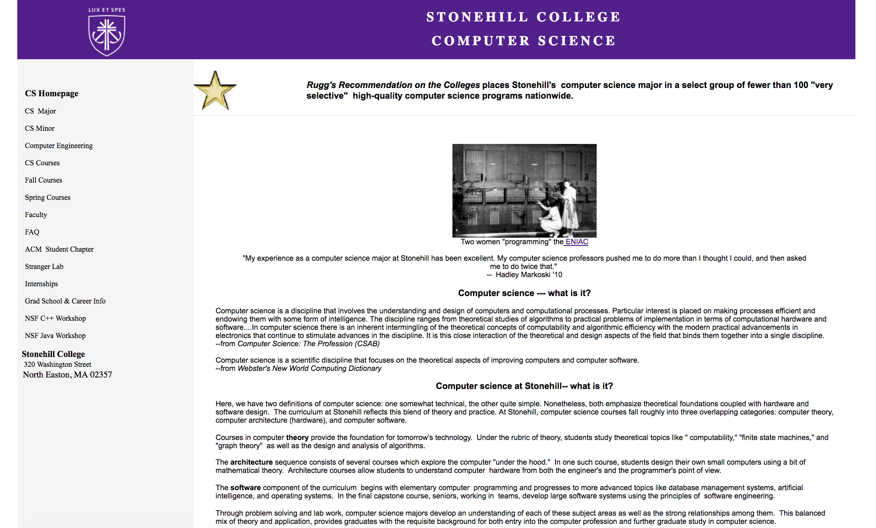We’ll have Ralph and Shai vote on the best web page.

You should attack this assignment in three phases:

Phase I: Content Cleanup

* remove all embedded formatting from the web pages so that they contain content ONLY. You can add some additional content if you want, but these pages will be publicly accessible... so don't do anything too risque.
* validate your new web pages to ensure they adhere to HTML 1.0 Strict (include an HTML 1.0 Strict validator link on each page)

Phase II: Content Organization

* think about patterns of content that appear in the web pages. For example, the home page has two types of content… blocks of text and a sort of “news flash” of recent events. The major, minor, and computer engineering pages have two types of content, a block of text and lists of items organized by headings. Organize these patterns of content across all of the web pages with <div> and <span> tags. A word of caution… avoid having too many div or span tags in your html… or you will simply be polluting the content with style again ([read this article](http://web.stonehill.edu/compsci/cs324/CSS/TableLayoutsvsDivLayouts.pdf)).

Phase III: CSS Design

* create an overall layout that will be common across web pages. You can get ideas for this layout from:
  + the course website
  + <http://www.csszengarden.com/>
  + <http://www.oswd.org/>
  + googling “css template open source”

You can use the css examples you find online as a starting point, but you should not be cutting and pasting css directly into your assignment solution. Your css should be as clean and organized as the html content pages you are creating.

* create a minimum of TWO sets of styles that can be applied to the web pages. One style should be for desktop displays (resolution 1280x1024), the other style should be for mobile displays specifically iPhone4 (960x640)..

Here’s an example of how you might approach the home page of the department:

* [Deparment Web Page (organized, but no css)](http://web.stonehill.edu/compsci/cs324/CSS/withoutcss.html)
* [Department Web Page (organized for desktop, with css)](http://web.stonehill.edu/compsci/cs324/CSS/withcss.html)

#### Grading

Up to two people per team can work on this project.

You should expect to spend 10 or more hours on this project.

* 40% pages are valid HTML5 and CSS3. Include an HTM5 validator link (like we did in class) so I can check each page.
* 40% - meet minimum requirements
* 15% - wow factor, did you impress me with your work
  + 0% you did the minimum
  + 5% not bad
  + 10% pretty good
  + 15% awesome
* 5% - wow factor, did you impress Ralph and Shai with your work

Submit a link to the bucket server url that will load the home page for your site. If two of you are working on the assignment, both of you should submit something to elearn so I get can give both of you a grade.