Creating Personal Website

CSC324 Advanced Programming

You should build a respectable set of web pages that tells me, the class, and potential employers
something about yourself. You CANNOT use a WYSIWYG editor like FrontPage, Homesite, or
Dreamweaver to build these pages... you have to create them with a simple text editor.

These pages will be publicly accessible... so don't do anything to risque. We’ll have the class vote on the best website.

You should produce a set of web pages including a minimum:
- A main page which introduces yourself and contains links to other pages
- A page containing your resume in html and doc (also optionally pdf) format (you can generate the html for the resume automatically. For example, you can save a Microsoft Word document as html).
- A page containing interesting links and descriptions of places on the web that you like to frequent
- A page containing links and descriptions of your buds (if any) on the net
- A page containing text, links, and images, sounds, videos, etc. of things you like to do for fun

These web pages will be something that you can show your friends, family, the class, and importantly potential employers/graduate schools.

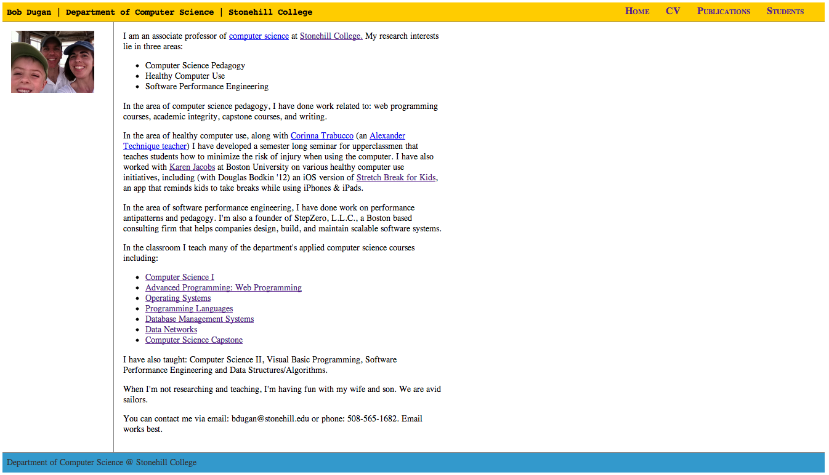
Grading

This is an individual effort, not a group effort.

You should expect to spend 5-10 hours on this project.

- 20% - pages are error free. A word of warning here... make sure any urls you use are RELATIVE and not absolute if they refer to a file in your web directory. For example:

<img src=”c:\stonehill\courses\cs321\projects\webdemos\sailing.jpg” alt=”sailing picture”>

Has problems, because if your web pages are installed on a different computer, the files that make
up your website might end up in a different directory. It’s better to do something like this:

<img src=”sailing.jpg” alt=”saling picture”>

Where sailing.jpg is a file in the same directory as the web page that is referring to it. This is called
a RELATIVE reference.

- 20% pages are valid HTML 5. You can validate your pages here http://validator.w3.org/
- 40% - meet minimum requirements
- 15% - wow factor, did you impress me with your work
  - 0% you did the minimum
  - 5% not bad
  - 10% pretty good
  - 15% awesome
- 5% - wow factor, did you impress the freshmen with your work

You may find that you want to use CSS style properties to make your website look more interesting. You are welcome to use CSS as long as you understand what you are using… in other words don’t grab a fancy CSS template from the web and drop it in your homework assignment. Be prepared to explain any CSS that you use.

Final steps:
- deploy your website to an Amazon Web Service Bucket Server
- submit the URL of the bucket server AND THE HOME PAGE that hosts your website so that I can grade the website and share the URL with the rest of the class.
- learn how to create and use an Amazon Web Service Bucket Server here: https://www.youtube.com/watch?v=LmO4PwhoKDA

