LECTURE OUTLINE FOR:
CHAPTER 5
NAMES, BINDINGS, TYPE CHECKING, SCOPE

INTRODUCTION

NAMES

VARIABLES (sextuple of characteristics)
Name
Address & Alias
Value
Type
Lifetime
Scope

BINDING
INTRODUCTION
TYPE BINDING
Static @ Declaration Time
Dynamic @ Runtime
Inferencing

STORAGE BINDING
Static
Stack Dynamic
Explicit Heap Dynamic
Implicit Heap Dynamic
TYPE CHEKCING
INTRODUCTION
EXAMPLES
STRONG TYPING
TYPE COMPATIBILITY

SCOPE
STATIC SCOPE
Problem #1
Problem #2
Problem #3

DYNAMIC SCOPE
LIFETIME
REFERENCING ENVIRONMENTS

NAMED CONSTANTS
VARIABLE INITIALIZATION

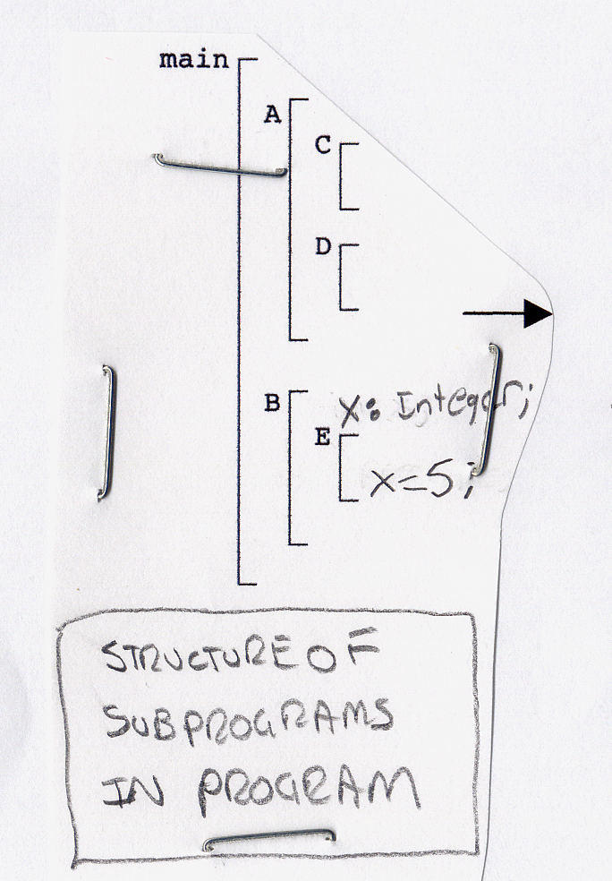
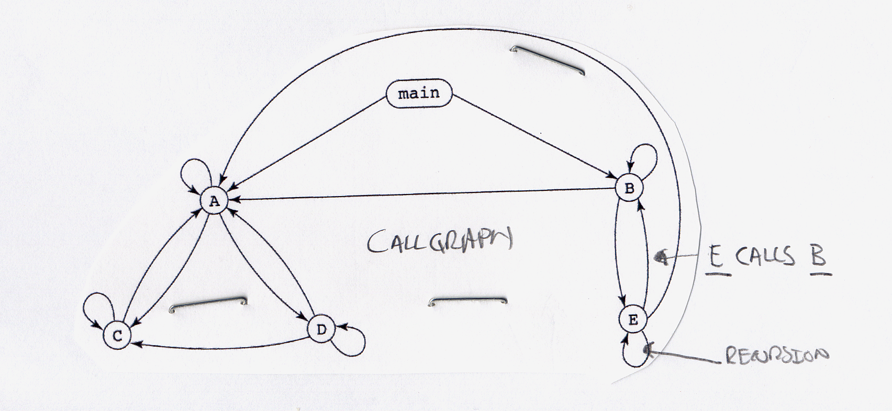
REFERENCING ENVIRONMENTS

procedure Example is
A, B, : Integer;
...

procedure Sub1 is
X, Y : Integer;
begin -- Sub1
... <============ 1
end;

procedure Sub2 is
X : Integer;
...

procedure Sub3 is
X : Integer;
begin –- Sub3
... <============= 2
end;

begin -- Sub2
... <============= 3
end;

begin -- Example
... <============= 4
endl;

Point Referencing Environment

