How mount a network share drive

Right click on START and select Explore:

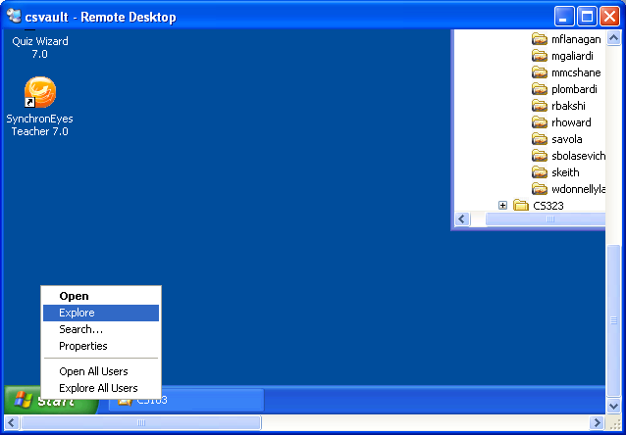

In the Explore window select Tools->Map Network Drive:

Important for Windows Vista Users! After clicking Explore, press the alt key which will make a menu pop up that has the “file, edit, view, favorites, tools” selection.

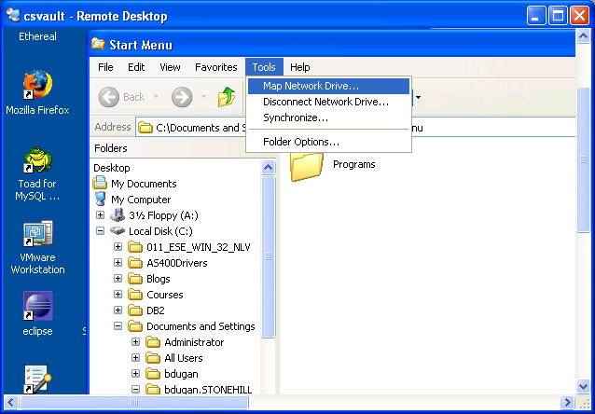

In the Map Network Drive window enter the drive share name as: \\10.114.11.46\<user> where <user> is your Stonehill userid:

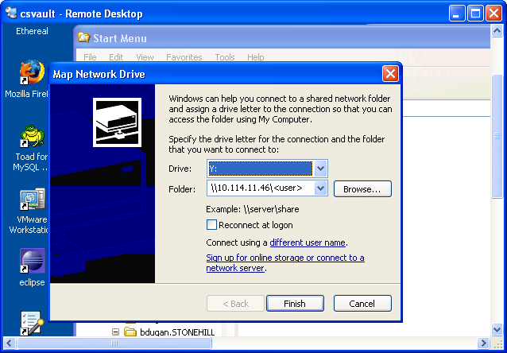

In the Map Network Drive Window click on the “Connect using a different user name:” link:

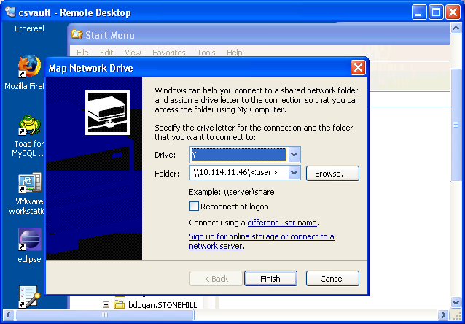

In the Connect As Window enter your Stonehill userid and password like this:

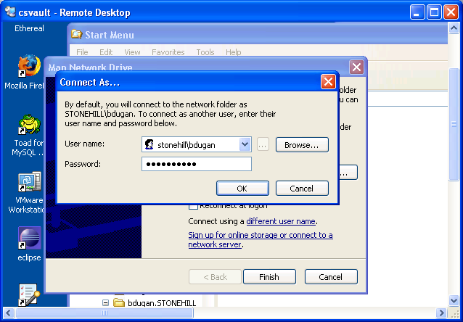

NOTE: Make sure you enter “stonehill\<user>” not “<user>” if you are on the dorm side of the campus.

Press OK in the Connect As window, then press Finish in the Map Network Drive Window.

If you look on the right hand side you should see a network attached drive with your userid as the name drive:

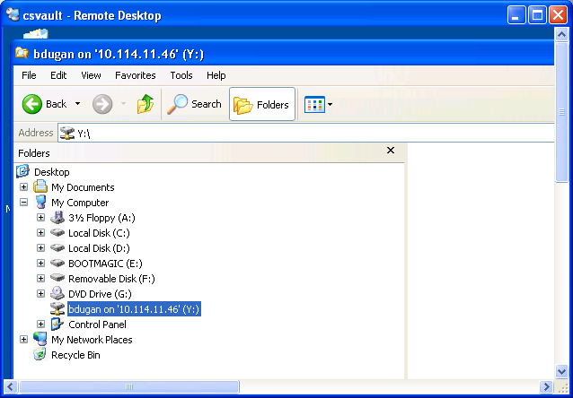

Create a folder for your homework assignment (e.g. Homework1), and copy the zipped versions of your programs for the homework assignment to the folder.

Good Luck!

