Using the SoundPlayer Class
Class: SoundPlayer
Object: SoundPlayer with which you can play any “.wav” sound file.
Methods or Operations:
play() – plays the “.wav” file
Example :player.play()
halt() – stops playing the “.wav” file
Example: player.halt()
setSoundFileName(filename) –the name of a “.wav” file to play. If the filename is relative, then the file is located relative to location of the program executable.
Example: player.setSoundFileName(“bird.wav”)
getSoundFileName() – returns a string with the filename of current “.wav” file to play. Example: Texbox1.Text = player.getSoundFileName()
Declaration and initialization:
‘Declare player as a SoundPlayer object:
Dim player As SoundPlayer = new SoundPlayer(Me,”bird.wav”)

The constructor takes two arguments. The first argument must be a form object. Usually in a Windows Application this is just “Me”. The second argument is the name of a “.wav” file. . If the filename is relative, then the file is located relative to location of the program executable.

Configuration:

In order for you to use this class you must:

- Install the DirectX 9.0 SDK on your system. This is located at:
http://msdn.microsoft.com/directx/sdk/

- Add a reference to the DirectSound library in your project (see me about this).
- Specify a “.wav” file. If you have an mp3 file that you want to use, you will need to convert the mp3 file to a wav file. There are a number of free conversion utilities located at:
http://www.mp3-converter.com/mp3_converter_shareware.htm

Here’s a sample Windows Application that uses the SoundPlayer class:
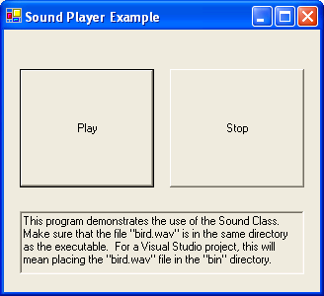
The code:
Public Class Form1
Inherits System.Windows.Forms.Form

' Create player as a variable accessible by even handlers in the form
Dim player As SoundPlayer = New SoundPlayer(Me, "bird.wav")

#Region " Windows Form Designer generated code "
...
#End Region

Private Sub PlayButton_Click(ByVal sender As System.Object, ByVal e As System.EventArgs) Handles PlayButton.Click
player.play()
End Sub

Private Sub StopButton_Click(ByVal sender As System.Object, ByVal e As System.EventArgs) Handles StopButton.Click
player.halt()
End Sub
End Class

