How to Use Classes and Objects in Visual Basic.NET

For every class that you want to use, there are two files.

- A DOCUMENTATION file which describes the how to use the class. You should read this file. It will tell you how to USE a class.

- A file which contains the VB.NET code for the class. You do not have to look at this file. However, this file must be “added” to your program.

Example: Suppose you wish to write a program using Dog objects.

Here is a description of the dog class. You should read this file. We will call this file Dog.doc:

class Dog

members
weight - Integer
sound - String

Initialization methods
Dog (weightValue As Integer, soundValue as String);

example:
‘ Fido is a 35 lb dog object who says woof-woof
Dim Fido as Dog = New Dog( 35, “woof-woof”)

‘ Rex is a 70 lb dog object who says bow-wow
Dim Rex as Dog = New Dog( 70, “bow-wow”)

Other methods:
getWeight () - returns the weight of the dog

setWeight(Dim weightValue as Integer) - changes dog weight

bark() - prints the dog’s barking sound

The following file contains the VB.NET code for the Dog class. You do not need to read or even understand the contents of this file. You simply add the file that contains this class in your program.

This file is called Dog.vb

Public Class Dog

Private weight As Integer
Private sound As String

Public Sub New(ByVal weightValue As Integer, _
ByVal soundValue As String)
weight = weightValue
sound = soundValue
End Sub

Public Sub bark()
Console.WriteLine(sound)
End Sub

Public Sub setWeight(ByVal weightValue As Integer)
weight = weightValue
End Sub

Public Function getWeight() As Integer
getWeight = weight
End Function

End Class

Note: All files which you need will be placed on the website for CS102.
How to Add a Class to your Visual Basic.NET Program

- The classes you’ll need to work with are on the CS102 website. Download the “.vb” file(e.g. Dog.vb or SodaMachine,vb) and save the file in the folder containing the VB.NET program that will use the class.

For example, let’s say you’re developing a program called “Kennel” that you want to have use the “Dog” class. Goto the course website, and RIGHT-CLICK on the “Dog Class” link:

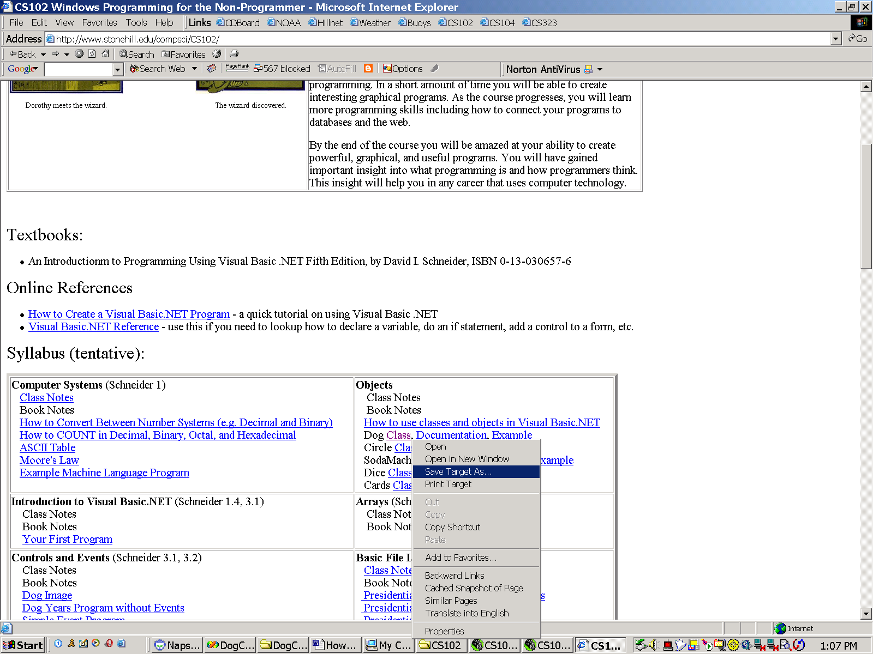

Select “Save Object As” and navigate through the folders on your computer until you find the one containing the VB.NET program you want to add the class too. In this case, we want to add the Dog class to the Kennel program. The program is located in a folder called “Kennel”:

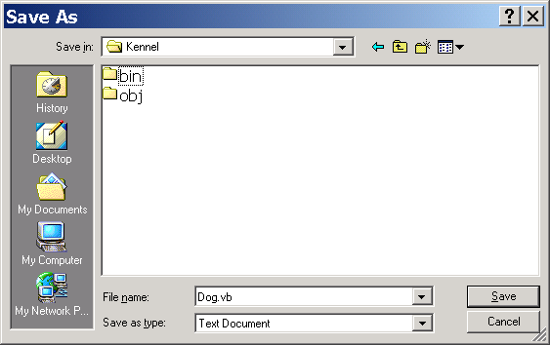

- Using Visual Studio, bring up the project that contains the program you are working on. In our example, this is the project “Kennel”:

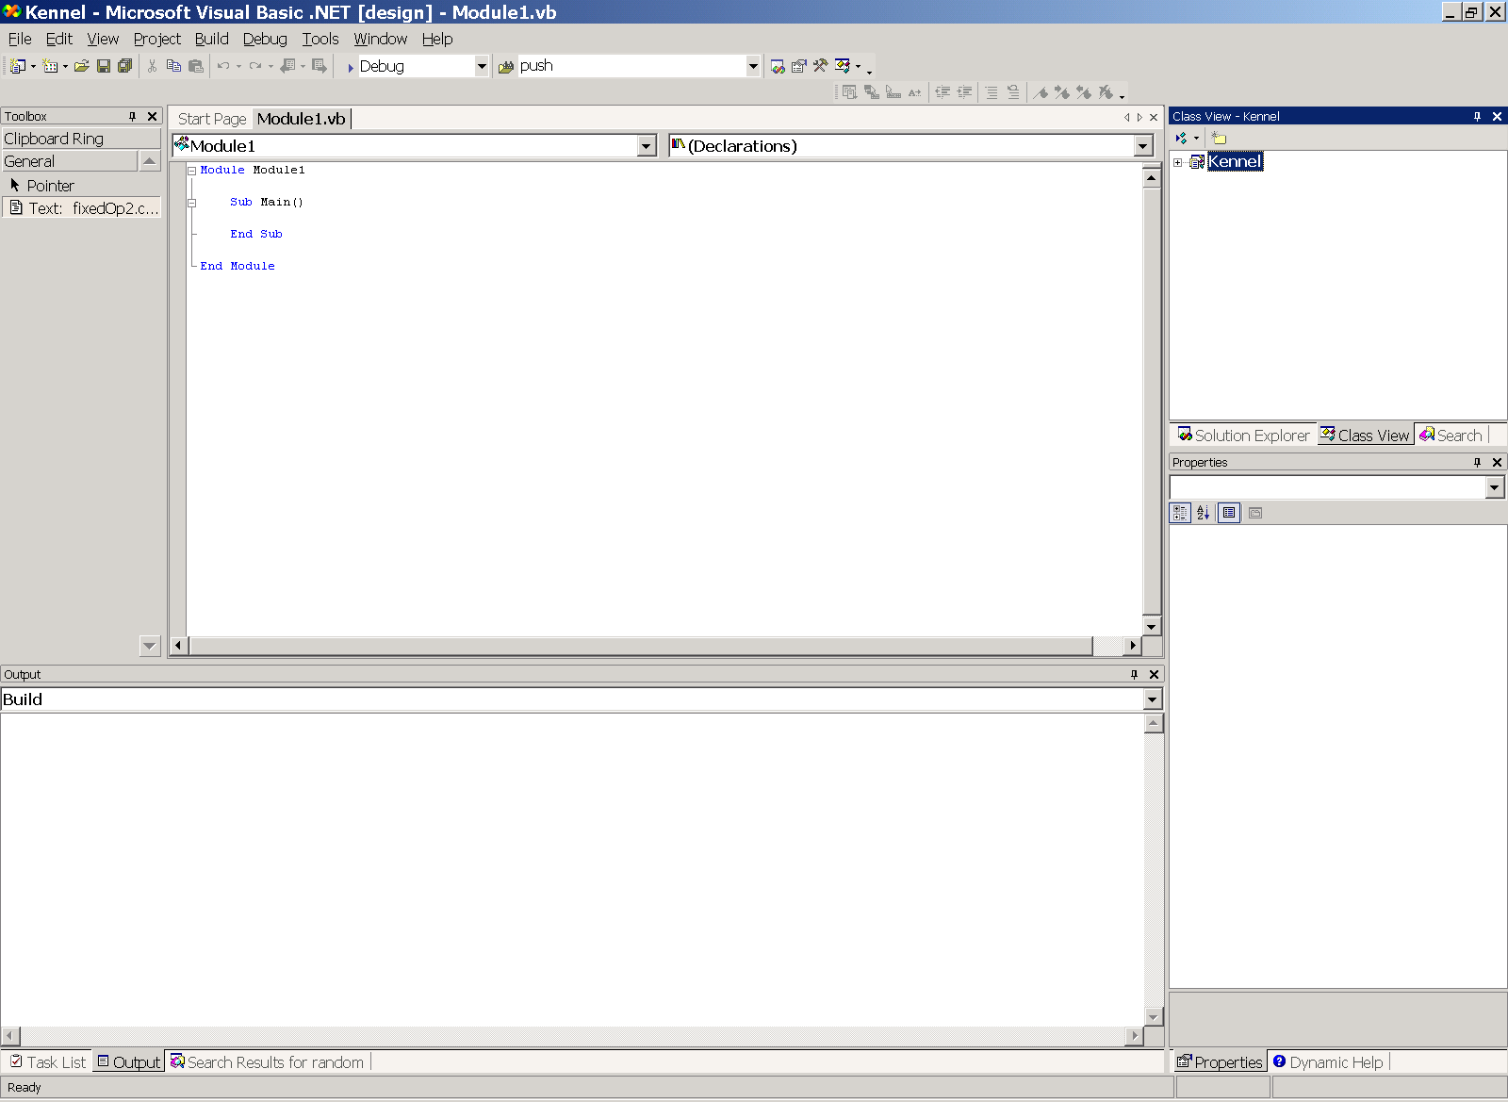
Solution
Explorer Tab

- Click on the Solution Explorer Tab in the upper right hand corner of the Visual Studio environment.

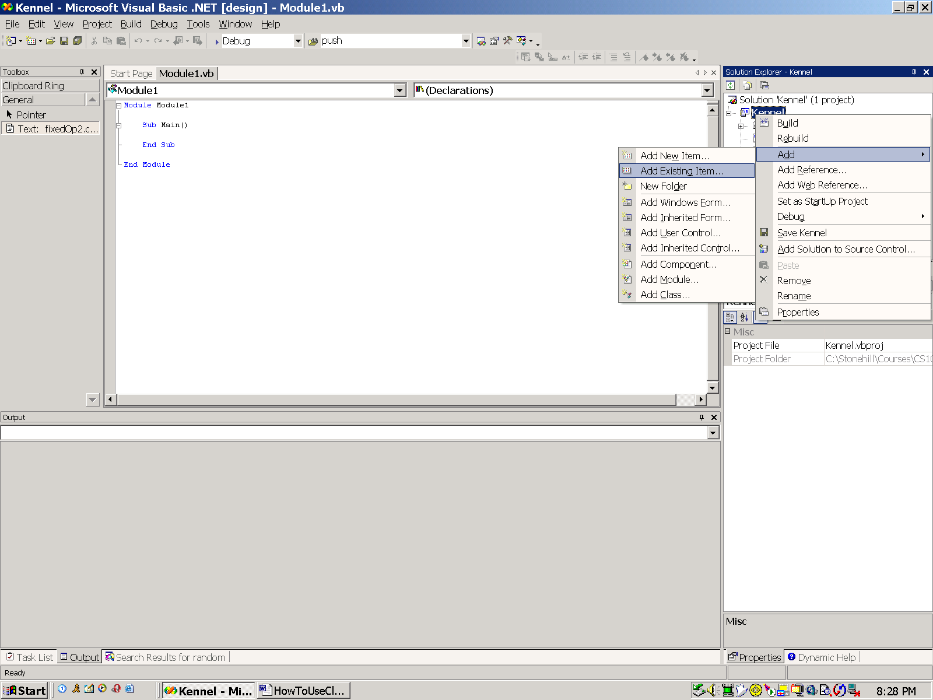

In the Solution Explorer window, right-click on the “Kennel” project then select Add->Add Existing Item.
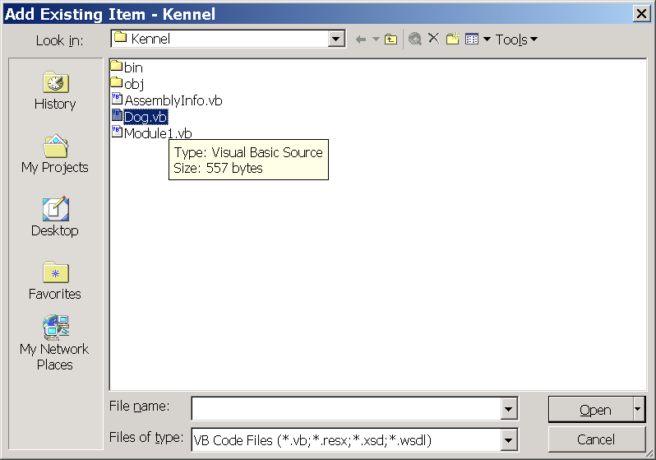

A file dialog will appear. Using the dialog, navigate to the folder containing the Kennel project.

You’ve already saved the Dog.vb file in this folder. Left click on the Dog.vb file and press the “Open” button.

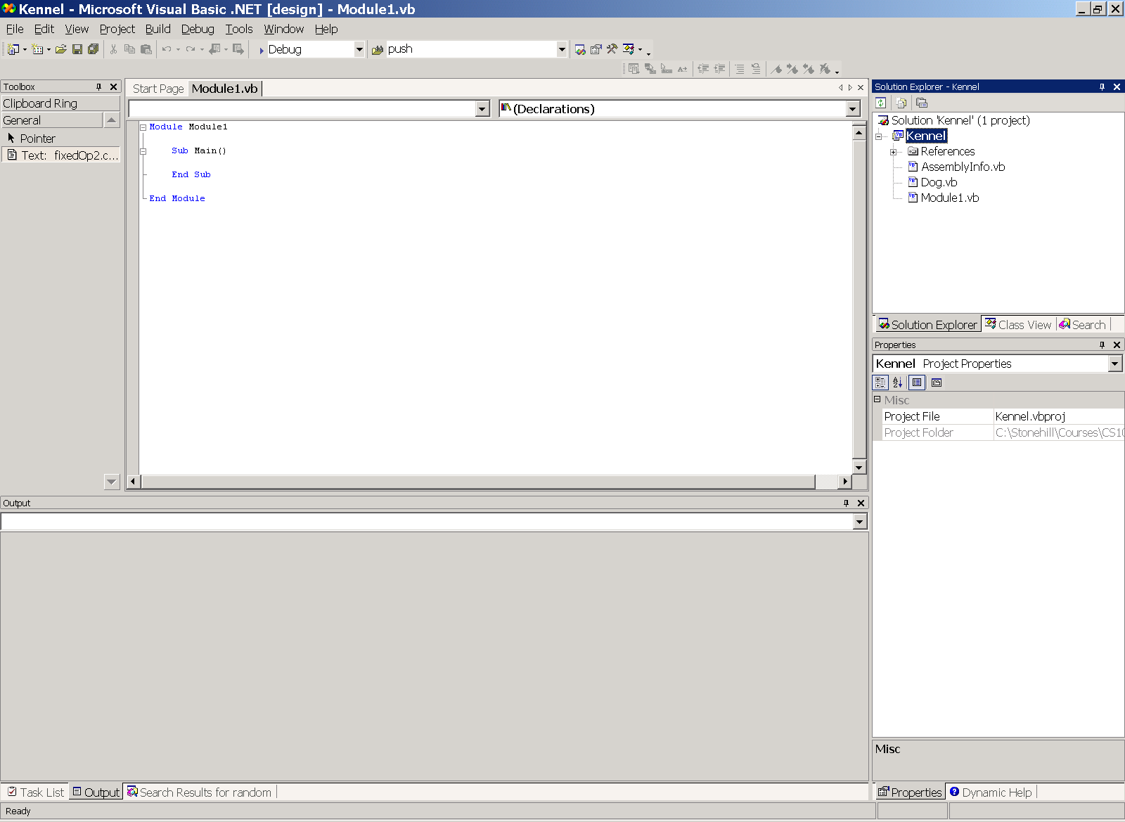

The Dog.vb file will be added to your project AND you will now be able to use the Dog class.

Add the following code to the Main subroutine:

Dim fido As Dog = New Dog(55, "woof-woof")

Console.WriteLine("My name is Fido. I weigh “ & fido.getWeight() & _
“ pounds “)
fido.bark()

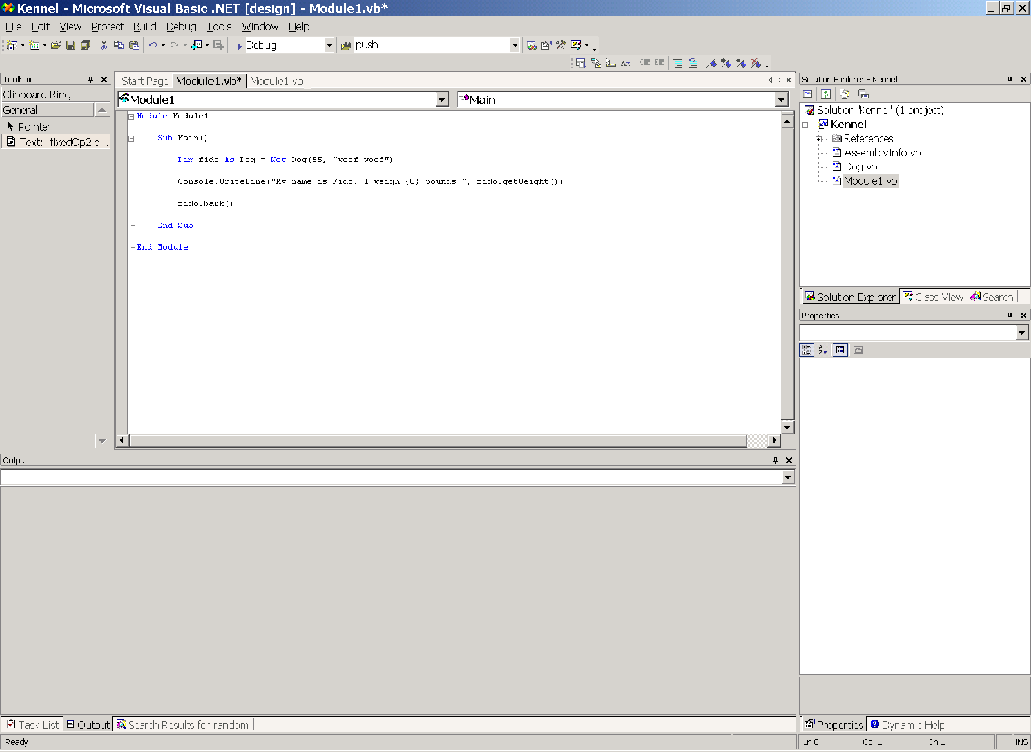

Build the program and run it!

