Using the Dice Class
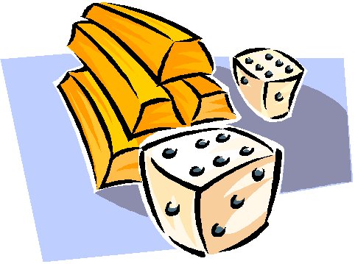
Class : Dice
The Object : any number dice
Methods:
roll() - returns an integer, the sum of the spots on all the dice
Declaration and initialization:
‘ d is a dice object i.e.two dice
Dim d As Dice = New Dice()

‘ x is a dice object with 3 dice
Dim x As Dice = New Dice(3)

‘y is a dice object with a single die
Dim y As Dice = New Dice(1)

Example:
Module Module1

Sub Main()
' We will be using 3 six sided dice
Dim d As Dice = New Dice(3)

' Roll the dice and output the results
Console.WriteLine("The roll of 3 six sided dice is: {0}", d.roll())

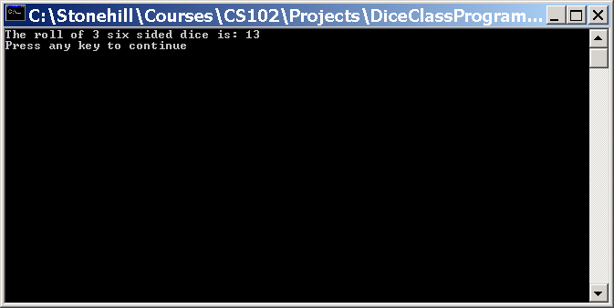
End Sub

End Module

