Visual Basic.NET Events
Class Exercises

Problem A:

Create a STORYBOARD and then a PROGRAM to ask the user a quiz question. Your program should have the following visual elements:

- Title
- Graphical Image
- Question
- Three possible answers with a button next to each
- Reset button

Your program should handle the following events:

- When an answer button is pressed, the text associated with the question text is altered to give the computer’s response to the answer.
- When the reset button is pressed, the text associated with the question text is reset to the original question.

BEFORE YOU START THE PROGRAM, DEVELOP A STORYBOARD SKETCH AND SHOW IT TO ME. Then create your program without events. Then add event handling to your program.

Problem B:
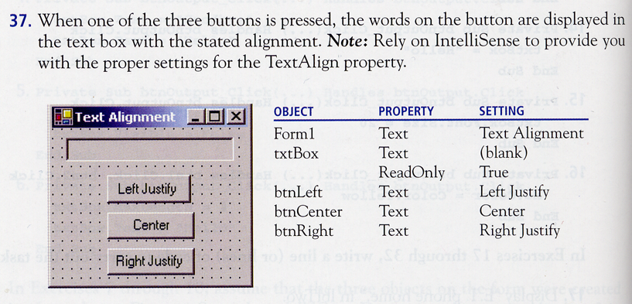

Problem C:

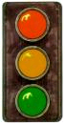
Simulate a traffic light with three small square text boxes placed vertically on a form. Initially, the bottom text box is SOLID GREEN, and the other text boxes are dark grey. When the Tab key is pressed, the middle text box turns yellow and the bottom text box turns grey. The next time the Tab is pressed, the top text box turns red and the middle text box turns grey. Subsequent pressing of the Tab key turns the bottom text box SOLID green, and the top text box grey.

HINT: When you press the Tab key, the input focus is changed from the current control to the next control. It’s basically the equivalent of the user clicking on the next control with the mouse. To get the Tab sequencing to work properly, first place the bottom text box on the form, then the middle text box, finally the top text box.

