Homework Two

CS102 Windows Programming for the Non-Programmer
Fall 2007
Date Assigned: 09-20-2007
Date Due: 09-27-2007 @ 11:59:59 PM

Instructions:

- Complete problems A, B, and C attached to this assignment.
- Create a zip file for each problem.
- Send an e-mail to bdugan@stonehill.edu with the zip files attached to the email.
- Complete this work by the due date above.

How To Install The WinZip Program:
The WinZip program is a nice tool for grouping and compacting files that you want to send via e-mail.

To install the zipfile program:
- goto: http://www.winzip.com/ddchomea.htm
- download the zipfile program
- install the zipfile program

How Create A WinZip File:

Let’s say you want to send a program to the TA. Microsoft’s Visual Studio programming environment creates a lot of files for you when you create a Visual Basic.NET program. You need to make sure that the TA gets ALL of the files that make up your program. The simplest way to do this is to use the WinZip program to put all of your program’s files into a single WinZip file. Then you can attach this file to an e-mail you send to the TA.

- Use the windows explorer to find the folder where your Visual Basic.NET program is located. You can figure out where this folder is by selecting Projects->Properties from the pulldown menu inside Visual Studio when you are editing your program:

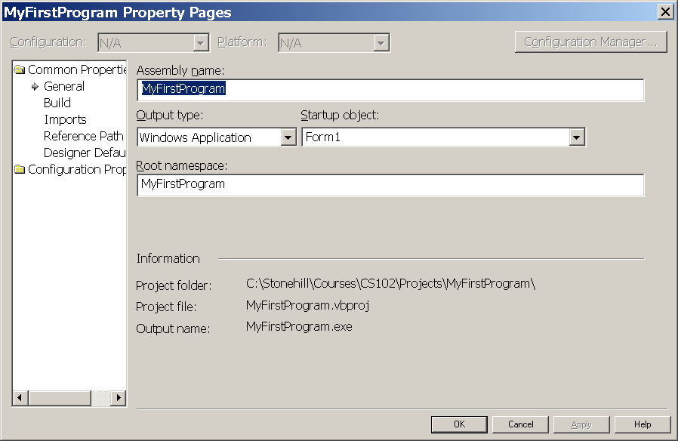

- As an example, I created a VB.NET program called “MyFirstProgram”. The files that make this program work are located in the folder located at:

C:\Stonehill\Courses\CS102\Projects\MyFirstProgram\

- Use Windows Explorer to find this folder

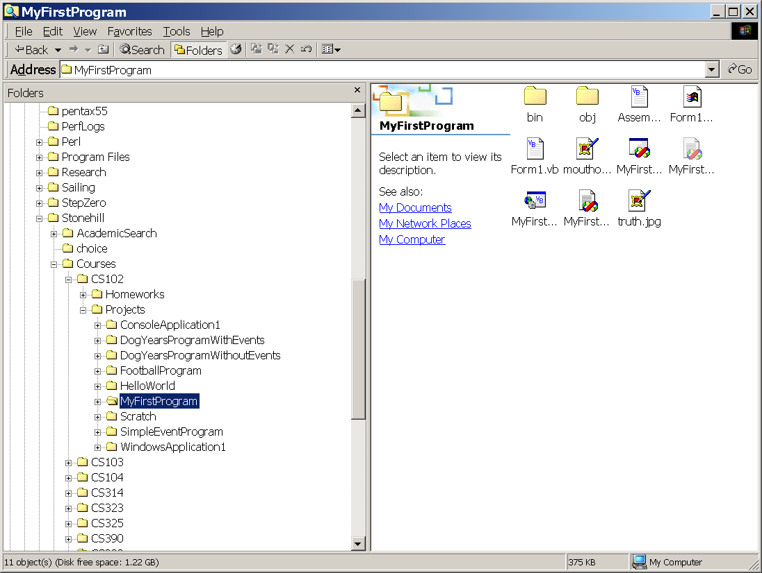

- Right-Click on the folder and select WinZip->Add to MyFirstProgram.zip

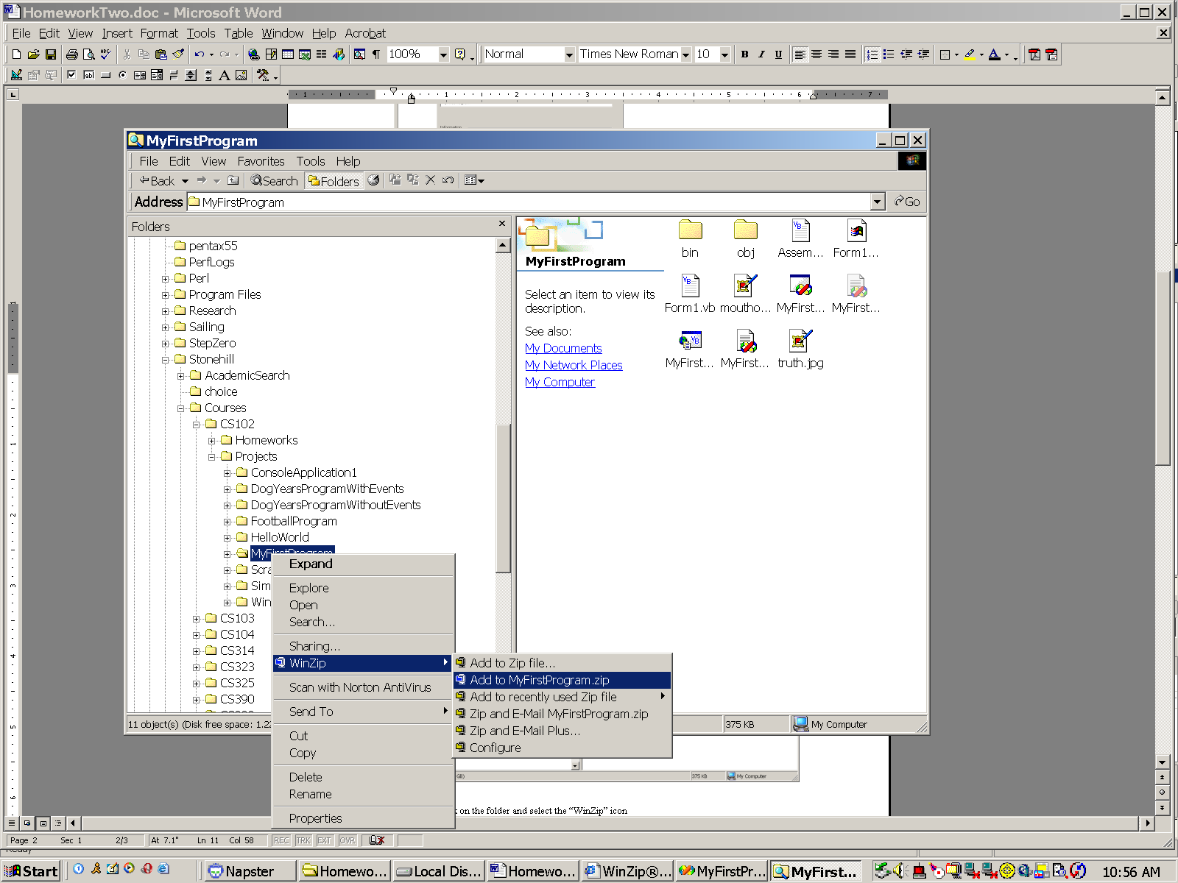

- Look in the folder directly ABOVE the folder you just zipped. There should be a special file there called “yourfoldername.zip”. In my example, this file is called “MyFirstProgram.zip”:

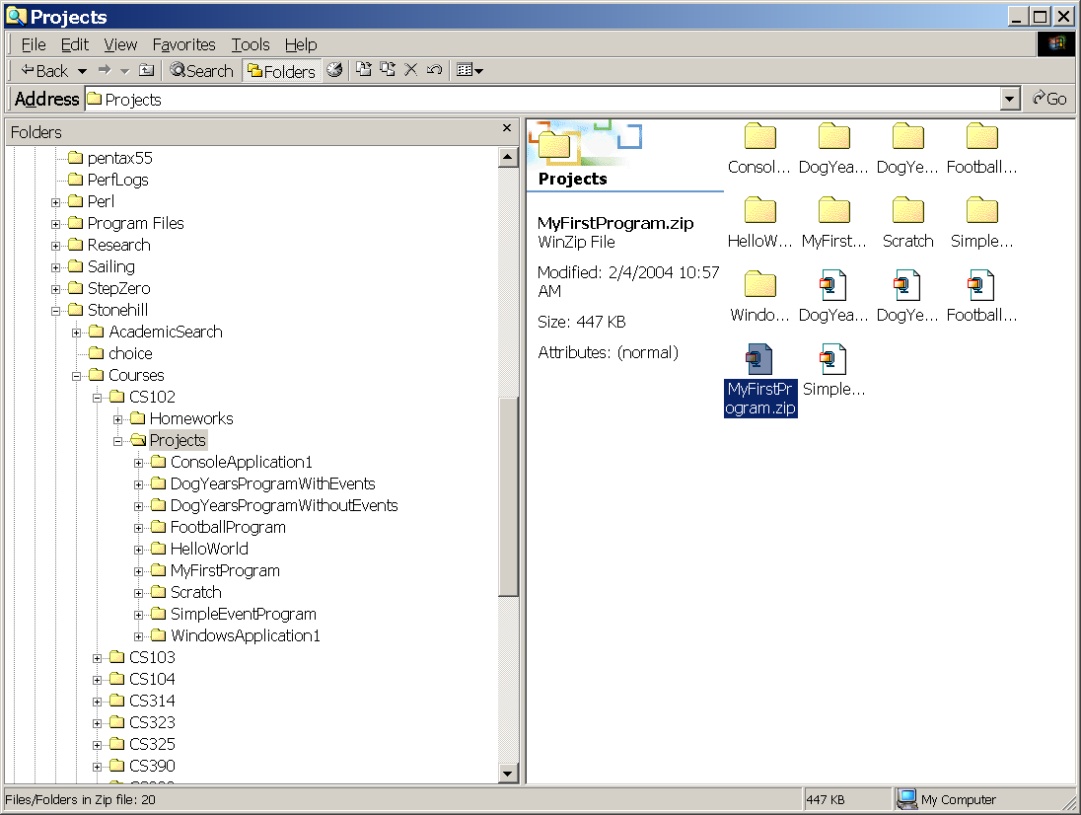
- Send an e-mail to the TA and attach the zip file you just created. In my example, this zip file is located at:

c:\Stonehill\Courses\Projects\MyFirstProgram.zip

How Extract Files From A WinZip File:

If you receive a WinZip file in an email, or you need download and use the contents of a WinZip file from a website, you need to follow these instructions.

- Place the ZipFile in a folder. For this course, the folder will usually be the same folder that holds the programming project you are working on.

- Goto the folder containing the ZipFile and right click on it. Select the “Extract-To-Here” option. In my example, we’re going to use the VendingMachine.zip file that you can get from the course website. It contains images that you need for Problem C.

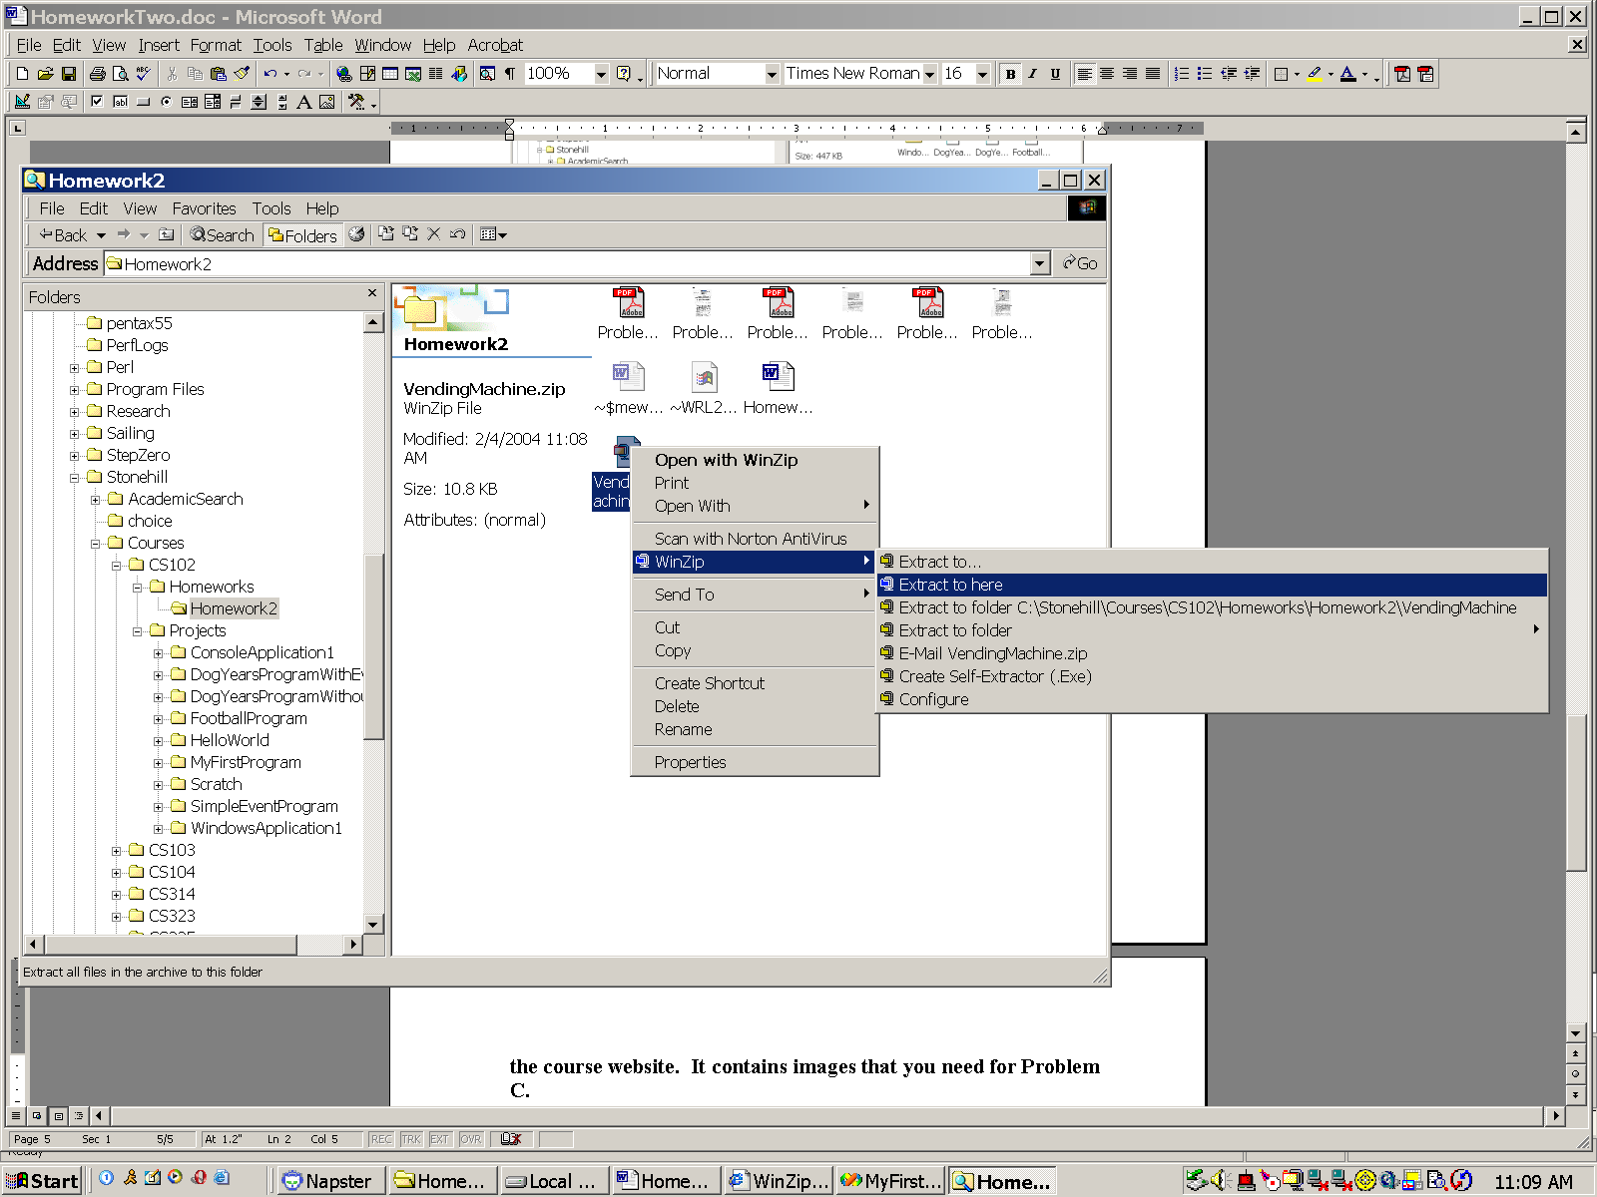
- The files contained in the WinZip file will be automatically extracted and placed in the same folder as the zip file.

