Homework Three

CS102 Windows Programming for the Non-Programmer
Fall 2007
Date Assigned: 09-27-2007
Date Due: 10-04-2007 @ 11:59:59 PM

Problem A:
Call the project Problem3A.
Create a console program that turns a light on and off (user input is in bold):

Light command: ON
The light is ON!

Next run:

Light command: OFF
The light is OFF!

Problem B:

Call the project Problem3B.

Create a GRAPHICAL version of Problem3A.

Write a GRAPHICAL program that allows the user to click on a button to turn the light on, and click on a different button to turn the light off.

When the button ON is pressed, an image depicting the light appears:

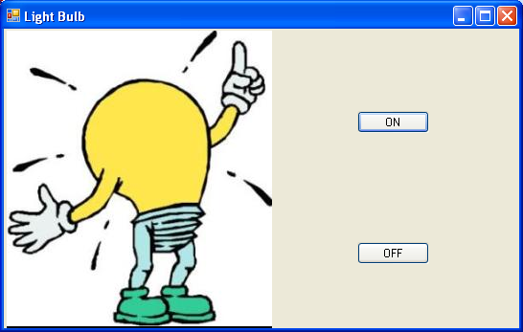

When button OFF is pressed, the image disappears:

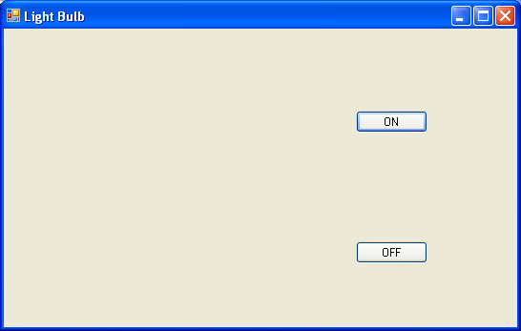

Problem C:

Create an application that contains then buttons and one label. The buttons should be labeled from 1 to 10. If button 1 is pressed, display 1 in the label. If button 2 is pressed display 2 in the label, and so on.

Submitting your Homework:

Use WinZip to create a zip file containing the project you created for each homework problem. For more on how to use WinZip see the description in Homework Two (http://www.stonehill.edu/compsci/CS102/HomeworkTwo.pdf).

Place your zipped files on your private network share. For more on how to access the private network share see:

http://www.stonehill.edu/compsci/cs103/HowToMountANetworkDrive.doc

