Homework Ten

CS102 Windows Programming for the Non-Programmer
Fall 2007
Date Due: 11-30-2007 @ 11:59:59 PM

Problem A:

This is a visual application.

Build your own soda machine using the soda machine class.

The soda machine should:
- allow the user to insert coins (1, 5, 10, or 25 cents) using buttons
- display the amount of money currently in the machine
- return the coins in the machine, updating the money amount displayed
- display the number of Cokes, Diet Cokes, Sprites, and Dr. Peppers in the machine
- allow the user to buy a specific soda, updating the money amount displayed and soda count displayed appropriately
- disallow a soda purchase if the user has not entered enough money

Be creative with the visual layout of the application!

Hint:

DECLARING A SODA MACHINE

To get this assignment to work, you are going to need to create an instance of the SodaMachine class... your soda machine... inside of your visual program. You DON’T want to create this instance within any event handler that you write. That’s because you don’t want the soda machine to disappear when you are done calling an event handler.

Your soda machine will have the same scope as all of the visual controls like the TextBox which you’ve been working with in visual programs since the beginning of the semester. You can access and manipulate these controls in event handler you write. If you declare your deck of cards right below the “Inherits” keyword at the top of the program like this:

Inherits System.Windows.Forms.Form
Dim sodamachine As SodaMachine = New SodaMachine()
Problem B:

This is a console application.

Write a program that will search a file of words (in lower case) and write the lexicographically largest and smallest words to the screen. The file contains nothing but words in lower case.

You can get to two sample files here:

http://www.stonehill.edu/compsci/cs102/homeworktenb1.txt

http://www.stonehill.edu/compsci/cs102/homeworktenb2.txt

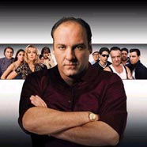
Problem C:
Some of you might have felt drawn to this course because you like games. Here's your chance to write your first one: BLACKJACK. If you want to learn more about the game of blackjack, check out this link.
You're going to write a modified version of blackjack that works like this: The deck is shuffled and the user is dealt two cards. The user can then choose to take up to 3 more cards from the deck. Each time a card is dealt, the user's points are recomputed.
Points are calculated based on the value of a card and the following point system:
- 2-10 = value of card is point value jack, queen, king = point value is 10
- ace = point value is 11
For example, if the user has 2 cards:
- Two of Hearts
- Ten of Clubs
then the user's point total is: 12.
If the user's point total is 21, the user wins and the game ends. If the user's point total exceeds 21, then dealer wins and the game ends. If the user's point total is less than 21, and the user doesn't want anymore cards, then it's the dealer's turn to draw cards from the deck.
The dealer draws up to five cards from the deck. The dealer stops drawing cards from the deck when her point total is greater than or equal to 16. If the dealer's point total is 21, then the dealer wins and the game ends. If the dealer's point total exceeds 21, then the user wins and the game ends. If the user's point total is less than 21 and the dealer's point total is less than 21 and the user's point total exceeds dealer's point total, then the user wins and the game ends. If the user's point total is less than 21 and the dealer's point total is less than 21 and the dealer's point total exceeds user's point total, then the user wins and the game ends.
Capiche?
Use the class Cards on the course website and make sure to shuffle the deck before each game.
You can download an executable here.
Sample run:

----------------------------- + Welcome to BlackJack! + -------------------------
You have 2 card(s): King of Clubs Ace of Diamonds
Points so far: 21
Do you want another card? (y/n): y
You have 3 card(s):
King of Clubs Ace of Diamonds Six of Clubs
Points so far: 27
Dealer wins!
Another game? (y/n):y

----------------------------- + Welcome to BlackJack! + -------------------------
You have 2 card(s): Four of Clubs King of Diamonds
Points so far: 14
Do you want another card? (y/n): y
You have 3 card(s): Four of Clubs King of Diamonds Jack of Diamonds
Points so far: 24 Dealer wins!
Another game? (y/n):y

----------------------------- + Welcome to BlackJack! + -------------------------
You have 2 card(s): Queen of Spades Jack of Hearts
Points so far: 20
Do you want another card? (y/n): n
Dealer draws a card.
Dealer has: 1 cards: Two of Hearts
Points so far: 2 Dealer draws a card.
Dealer has: 2 cards: Two of Hearts Ace of Diamonds
Points so far: 13
Dealer draws a card. Dealer has: 3 cards: Two of Hearts Ace of Diamonds Jack of Spades
Points so far: 23
You won! Another game? (y/n):n

HINTS:
You can figure out the face value of a card using this expression:

Dim face As Integer = card Mod 100

this will return a number 1,2,3,4 which stands for hearts, diamonds, clubs, spades

You can figure out the suit value of a card using this expression:
Dim suit As Integer = Math.Floor(card / 100)

this will return a number 1 to 13 which stands for ace, two, three, four, five, six, seven, eight, nine, ten, jack, queen, king

SMACKDOWN Problem (Add one point to final exam score):

Use the Cards class (located on the course website) to create a simple 5 card poker hand dealing program.

When the user first brings up the program, an empty hand is displayed:

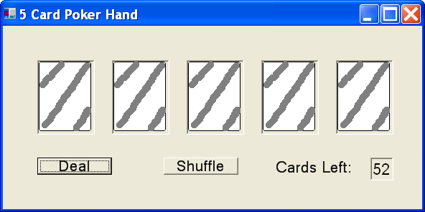

Use a PictureBox for each card that will be dealt to the user (there are 5 cards). Initially, each PictureBox should contain the image “empty.gif”.

When the user clicks on the “Deal” button, 5 cards are dealt from the deck:

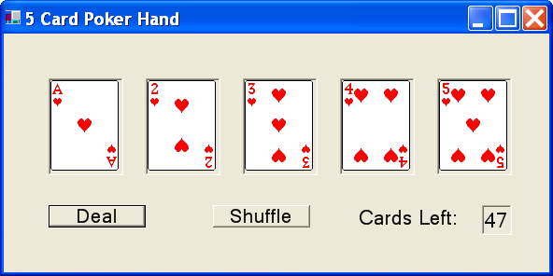

An image corresponding to each card dealt is displayed in a PictureBox. There are 5 picture boxes for the five cards dealt. Notice also that the number of cards left has been decremented by 5. Notice also that the cards are appearing in order because the cards were never sorted.

The user can click on the deal button over and over again. Each time 5 cards will be dealt from the deck, and the number of cards left will be decremented:

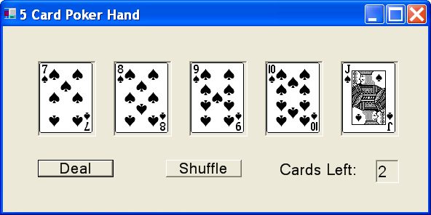
At this point, if the user clicks on the “Deal” button, you program should determine that there aren’t enough cards in the deck to deal 5 cards. A warning dialog is displayed to the user:
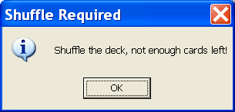
And the user is not allowed to “Deal” any more cards until the shuffle button is pressed.

When the shuffle button is pressed. The cards are shuffled, the PictureBox images are reset to “empty.gif”, and the number of cards left is reset to 52:

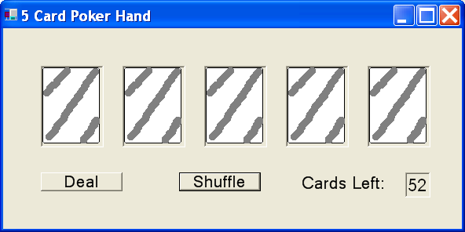
If the user presses the “Deal” button again, 5 cards are dealt:

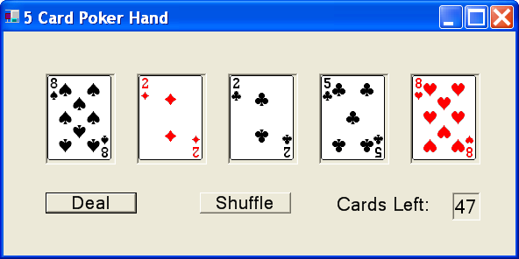
Notice that the cards in the hand are now random, because we actually shuffled the deck.

DECLARING A DECK OF CARDS:

To get this assignment to work, you are going to need to create an instance of the Card class... your deck of cards... inside of your visual program. You DON’T want to create this instance within any event handler that you write. That’s because you don’t want the deck of cards to disappear when you are done calling an event handler.

Your deck will have the same scope as all of the visual controls like the TextBox which you’ve been working with in visual programs since the beginning of the semester. You can access an manipulate these controls in event handler you write. If you declare your deck of cards right below the “Inherits” keyword at the top of the program like this:

Inherits System.Windows.Forms.Form
Dim deck As Cards = New Cards()

Your deck of cards will have the same scope as the visual controls.

MAPPING CARD TO AN IMAGE FILE

You can figure out the face value of a card using this expression:

Dim face As Integer = card Mod 100

You can figure out the suit value of a card using this expression:
Dim suit As Integer = Math.Floor(card / 100)

You can use the combination of face and suit to generate the name of one of the 52 gif files that I’ve provided for this project. The gif files have the following pattern:

<face><suit>.gif

Where <face> is: a,2,3,4,...9,10,j,q,k
Where <suit> is: h,d,c,s

For example, the file “ah..gif” will contains the image for an Ace of Hearts. The file “10s.gif” contains the image for the Ten of Spades.

If you want a PictureBox to change the image that it is displaying, use this line of code:

CardBox1.Image = Image.FromFile(“empty.gif”)

This will display the image stored in the file empty.gif in the picture box CardBox1. YOU MUST PLACE ALL IMAGES IN THE “BIN” DIRECTORY OF YOUR PROJECT!!!.

HINTS:

You can find an executable version of this program (Problem11B.exe), the Cards class (Cards.vb), the Cards class documentation (Cards.doc), and the images you need here: http://www.stonehill.edu/compsci/CS102/Programs/HomeworkEleven.zip
- Once you click on the above link, a window will appear. Press the “Open” button and you will see a list of files you can select from.
- Double click on the file “Problem11B.exe” to turn the program.
- You can run it with different data. You might run the program to compare it to your own output.
- NOTE: this is a binary file. You will NOT be able to read the code in Visual Studio or any other editor.
Submitting your Homework:

Place your homework on your private network drive.

