Homework Six

CS102 Windows Programming for the Non-Programmer
Fall 2007
Date Due: 10-24-2007 @ 11:59:59 PM

Problem A:

Call the project Problem6A.

Write a program that determines whether a meeting room is in violation of fire law regulations regarding the maximum room capacity. The program will read in the maximum capacity and the number of people to attend the meeting. If the number of people is less than or equal to the maximum room capacity, the program announces that it is legal to hold the meeting and tells how many additional people my legally attend. If the number of people exceeds the maximum room capacity, the program announces that the meeting cannot be held as planed due to fire regulations and tells how many people must be excluded in order to meet the fire regulations.

Here are two sample runs of the program:

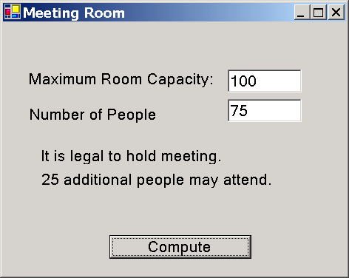
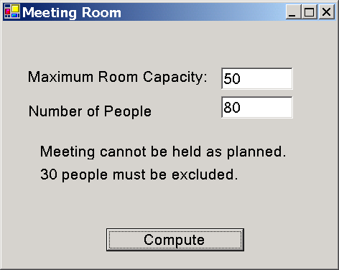

You find an executable version of this program here: http://www.stonehill.edu/compsci/CS102/Programs/RoomCapacity.exe
- You can run it with different data. You might run the program to compare it to your own output.
- NOTE: this is a binary file. You will NOT be able to read the code in Visual Studio or any other editor.
HINT ONE: Make sure that you compare the Integer value of the user’s input, NOT the String value.
(“bob” > “anna”) is True because the “b” comes before “a” in the alphabet... and the ASCII character “b” is greater than the ASCII character “a”.

( “75” > “100”) is True because we’re treating the constants “75” and “100” as ASCII characters, not integers. The ASCII character for “7” is greater than the ASCII character for “1”. Weird huh?

(75 > 100 ) is False because we’re treating the constants 75 and 100 as integers. 75 is NOT greater than 100.

HINT TWO: I needed TWO labels for the two lines of output that appear after the user presses the Compute button.

Submitting your Homework:

Place your homework on your private network drive.

