Homework Seven

CS102 Windows Programming for the Non-Programmer
Fall 2007
Date Due: 11-02-2007 @ 11:59:59 PM

Problem A:

Call the project Problem 7A.

Write a console application to score the Rock, Paper, Scissor game. Each of two users selects rock paper or scissors by entering P, R, or S, then the program announces the winner as well as the basis for determining the winner:

Paper covers Rock
Rock breaks Scissors
Scissors cuts Paper
Tie

Make sure you allow the user to handle upper and lower case letters… also make sure you handle invalid input.

Problem B:

Call the project Problem 7B.

An employee is paid at a rate of $16.78 per hours for regular hours worked in a week. Any hours over that are paid at the overtime rate of one and one half times that. From the worker’s gross pay, 6% is withheld for social security tax, 16% is withheld for federal income tax, 5% is withheld for state tax, and $10.00 per week is withheld for union dues. If the worker has three or more dependents, then an additional $35 is withheld to cover the extra cost of health insurance beyond what the employer pays. Write a program that will take in the number of hours worked in a week and the number of dependents, as input, and will then output the worker’s gross pay, each withholding amount and the net take-home pay for the week.

Here are some sample runs of the program:

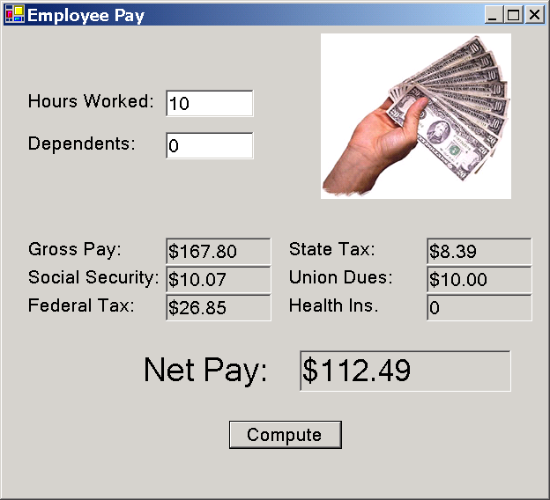

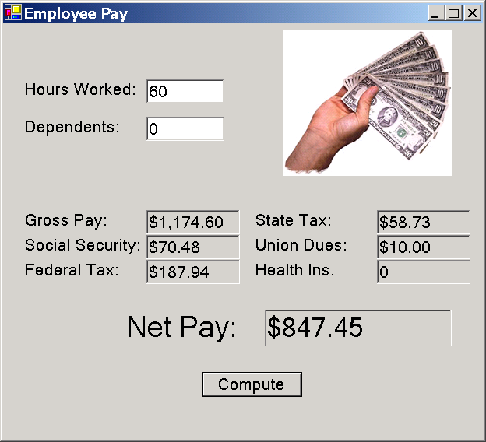
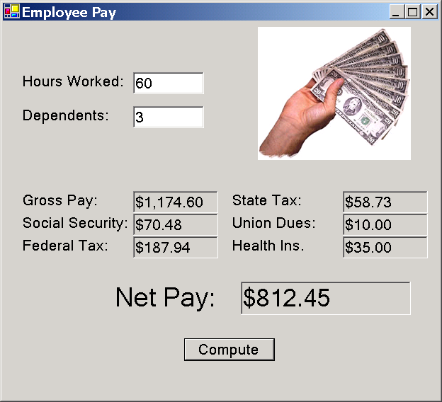

You find an executable version of this program (Program5B.exe) here: http://www.stonehill.edu/compsci/CS102/Programs/HomeworkFive.zip
Submitting your Homework:

Use WinZip to create a zip file containing the project you created for each homework problem. For more on how to use WinZip see the description in Homework Two (http://www.stonehill.edu/compsci/CS102/HomeworkTwo.pdf).

Send the zip files in an e-mail to: cs102@stonehill.edu

