Homework Nine

CS102
Fall 2007
Date Due: 11-16-2007 @ 11:59:59 PM

Problem A:

This program is NON-VISUAL!

Write a program that displays a Celsius-to-Fahrenheit conversion table. Entries in the table should range from –40 to 40 degrees Celsius in increments of 5 degrees.

HINT: You can use this formula:

f = (9/5) * c + 32

to convert from Celsius to Fahrenheit.
You find an executable version of this program (Problem7A.exe) here: http://www.stonehill.edu/compsci/CS102/Programs/HomeworkSeven.zip
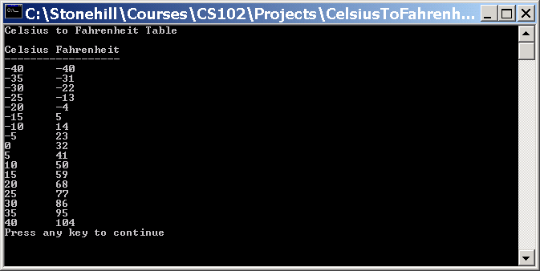
Problem B:

This program is NON-VISUAL!

Ask for a triangle side length and use “*”s to display an isosceles right triangle with two of the sides equal to the length (user input is shown in bold):

Enter length of triangle side: 10
*
**
***
****
*****
******
*******
********
*********
**********
Again (y/n): Y

Enter length of triangle side: 5
*
**
***
****
*****
Again (y/n): Y

Enter length of triangle side: 2
*
**
Again (y/n): N

You find an executable version of this program (Problem7B.exe) here: http://www.stonehill.edu/compsci/CS102/Programs/HomeworkSeven.zip

Problem C:

This program is NON-VISUAL!
Write a menu-driven program that allows a user to enter N numbers and then choose between finding the smallest, largest, sum or average. Use a select statement to determine what action to take. Provide an error message if an invalid choice is entered. Note that this program will continue to run until the user selects option (5).
Sample Output:
How many numbers do you want to enter? 5
Enter 5 integers: 18
21
7
54
9
Select from the following choices:
1) Smallest
2) Largest
3) Sum
4) Average
5) Exit
Choice: 1
The smallest number is: 7
Select from the following choices:
1) Smallest
2) Largest
3) Sum
4) Average
5) Exit
Choice: 3
The sum is: 109
Select from the following choices:
1) Smallest
2) Largest
3) Sum
4) Average
5) Exit
Choice: 9
Invalid Choice!
Select from the following choices:
1) Smallest
2) Largest
3) Sum
4) Average
5) Exit
Choice: 5
Goodbye! Have a nice day!

SMACKDOWN (Optional):
[Complete this SMACKDOWN problem and add one point to your final exam grade.]

Two numbers are called amicable if the proper divisors of one sums to the other.
For example, the pair 220 and 284 are amicable numbers:
The proper divisors of 220 are: 1+2+4+5+10+11+20+22+44+55+110 = 284
The proper divisors of 284 are:
1+2+4+71+142 = 220
Note: 1 is considered a proper divisor, but the number itself is not a proper divisor.
Small amicable pairs are very scarce. Some amicable pairs are (6232, 6368), (10744,10856), (17296, 18416), and (9363584, 9437056).
In Greek mythology, amicable numbers were thought to posses strange mystical powers. Astrologers used them in drawing up horoscopes.
Write a program which accepts two integers and determines whether or not the integers form an amicable pair.
Allow the user to repeat the calculation as many times as he/she wishes. (see sample run).
Your program should include one for loop.
Click here to read more about amicable numbers.
Sample run:
Enter two numbers: 220 284
220 and 284 are amicable
Run again? Y or y for Yes: y
Enter two numbers: 1000 1024
1000 and 1024 are not amicable
Run again? Y or y for Yes: n
Bye.

Submitting your Homework:

Place your homework on your private network share drive.

