Homework Four

CS102 Windows Programming for the Non-Programmer
Fall 2007
Date Due: 10-12-2007 @ 11:59:59 PM

Problem A:

Call the project Problem4A.

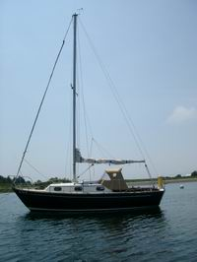
My brother Tim flew up from Texas to go sailing on my sailboat "Cricket". He wanted to sail from Salem Harbor in Salem, MA to Rockport Harbor in Rockport, MA. The one way distance for this trip is 18 Nautical Miles. Tim wanted to know far that was in "regular miles".

A Nautical Mile is equal to one minute of latitude on the earth's surface or 1.1508 regular miles. Tim also wanted to know how long it would take to travel this distance. Cricket travels at a top speed of 5.8 Knots (Nautical Miles per hour) and an average speed of 4 Knots.
Write a Console (not a graphical) program to help answer Tim's questions. The program should take a distance in nautical miles, a top speed, and an average speed and compute/display the distance in regular miles, the estimated travel time in hours at top speed and the estimated travel time in hours at average speed.
Here’s some sample output from the program:

Enter the distance to travel in nautical miles: 18
Enter the top speed of the boat in knots: 5.8
Enter the average speed of the boat in knots: 4.0

***** Results *****
The distance to travel in regular miles is: 20.7144 miles
The best case travel time is: 3.10344827586207 hours at 5.8 knots
The average case travel time is: 4.5 hours at 4 knots
You find an executable version of this program (Program4A.exe) here: http://www.stonehill.edu/compsci/CS102/Programs/HomeworkFour.zip
- Once you click on the above link, a window will appear. Press the “Open” button and you will see a list of files you can select from.
- Double click on the file “Program4A.exe” to turn the program.
- You can run it with different data. You might run the program to compare it to your own output.
- NOTE: this is a binary file. You will NOT be able to read the code in Visual Studio or any other editor.

Problem B:

Call the project Problem4B.

Create a GRAPHICAL version of Problem4A.

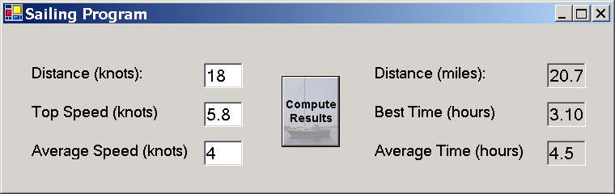

The “Compute Results” button is a regular button with the Image property set to a jpeg image of “Cricket”. You can use this image or one of your own. The image is called “CricketButton.jpg” located in the zip file at: http://www.stonehill.edu/compsci/CS102/Programs/HomeworkFour.zip

You find an executable version of this program in the zip file. The program is called “Problem4B.exe”.

Problem C:

Call the project Problem4C.

Write a GRAPHICAL program that allows the user to specify two numbers and then adds, subtracts, multiplies, or divides them when the user clicks on the appropriate button. The output should give the type of arithmetic performed and the result.
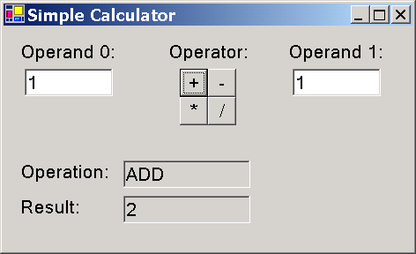

NOTE: One problem I ran into getting this program to work is trying to ADD two text fields. I had an expression that looked like this:

result.Text = (operand0.Text + operand1.Text)

As it turns out, VB.NET thinks that the “+” operator is the same thing as the “&” operator when the operands are both strings. The result is a string concatenation instead of an addition.

For example if operand0.Text is “1” and operand1.Text is “1”, then result.Text will be “11” instead of “2”. “11” is the concatenation of the strings “1” and “1”.

To fix this problem, you can force Visual Basic to interpret the operands as Integers using a special subroutine called “CInt()”:

result.Text = (CInt(operand0.Text) + CInt(operand1.Text))

Assuming both operands are the string “1”, this CInt() subroutine force them to be converted to integers before applying the “+” operand. And the result.Text will be “2” which is what you want.

You don’t need to do this CInt() thingy for the other operands -,* and / because VB.NET knows that these three operands only work with numbers.
You find an executable version of this program (Program4C.exe) here: http://www.stonehill.edu/compsci/CS102/Programs/HomeworkFour.zip
Submitting your Homework:

Winzip your projects and place them on your private network drive:\\10.114.11.46\<userid>. For more information on how to do this see:
http://www.stonehill.edu/compsci/cs103/HowToMountANetworkDrive.doc

