Homework Five

CS102 Windows Programming for the Non-Programmer
Fall 2007
Date Due: 10-19-2007 @ 11:59:59 PM

Problem A:

Call the project Problem5A.

Ermestina Money works in a small candy store. Her customers do not like receiving a lot of heavy change. (No customer wants to receive 99 pennies in change!) Write a program to assist Ernestina calculate change for her customers. Your program should accept an amount of change under one dollar (an integer) and calculate the minimum number of coins (fifty-cent pieces, quarters, nickels, dimes, pennies) needed for that amount.
Initially your program looks like this:
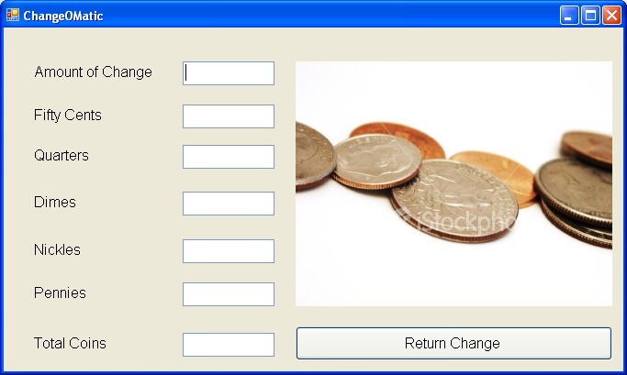
The user enters the amount of change in cents (always less than one dollar), for example, 72 cents, and presses the RETURN CHANGE BUTTON:

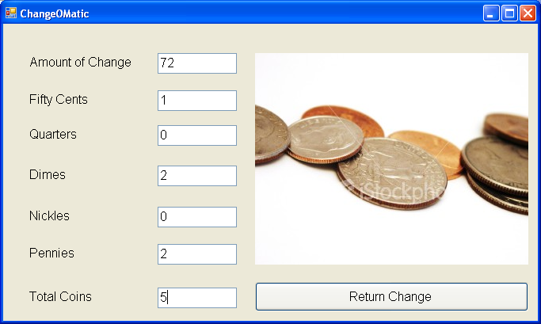
The user enters the amount of change in cents (always less than one dollar), for example, 31 cents, and presses the RETURN CHANGE BUTTON:
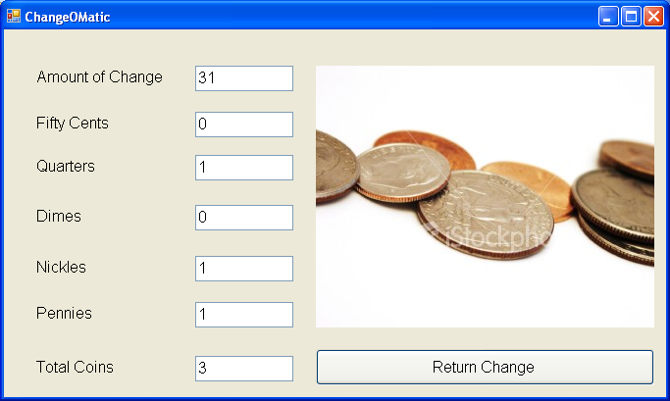

Problem B:

Call the project Problem5B.

Workers at a particular company have won a 7.6% pay increase retroactive for six months. Write a program that takes and employee’s previous annual salary as input and outputs the amount of retroactive pay due to the employees, the new annual salary, and a new monthly salary.

This program should be a console application.

Here is a sample run of the program (user input is in red):

Enter previous salary: 50000.00
New annual salary $53800
New monthly salary $4483.33
Retroactive salary due: $1900

Submitting your Homework:

Winzip your projects and place them on your private network drive:\\10.114.11.46\<userid>. For more information on how to do this see:
http://www.stonehill.edu/compsci/cs103/HowToMountANetworkDrive.doc

