Homework Eleven

CS102 Windows Programming for the Non-Programmer
Fall 2007
Date Due: 12-11-07 @ 11:59:59 PM

Problem A:

This program is NON-VISUAL!

Write a program to compute the numeric grades for a course. The course records are in a file that will serve as the input file (grades.txt). The input file is in the following format:

bob smith
80
70
60
90
75
88
99
100
77
92
jane jones
87
90
90
90
75
78
89
90
97
82
etc.

Each student name appears on a single line. This is followed by ten integer grades. The pattern of student names and grades continues until the end of file is reached. Your program can assume that there are always ten grades after a student’s name. Your program cannot assume how many students there are in the grades.txt. file.

The output for the program should be a file (output.txt) which replicates the format of the input file, with an average line added at the end of each list of student grades:

bob smith
80
70
60
90
75
88
99
100
77
92
Average is: 83.1
jane jones
87
90
90
90
75
78
89
90
97
82
Average is: 86.8
etc.

Problem B:

Who wants to be a millionaire?

How much money do you think you need to retire comfortably? If you were a millionaire right now, do you think that you would have enough money?

Write a VISUAL program that determines how many years a user can spend in retirement before depleting his/her savings:

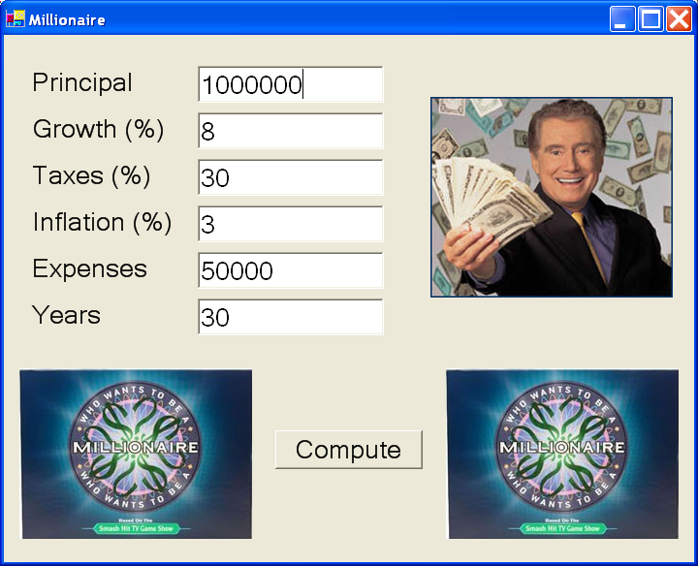

The user will provide the following information:

- Principal: how much money the user begins retirement with. In the example above, the user starts with one million dollars.

- Growth: by what percentage the user expects the principal to grow every year. In this example, the user expects the principal to grow by 8%. If you are a good investor, you can reasonably expect to earn between 6 and 10% growth on your principal each year.

- Taxes: the user’s annual federal and local income tax rate. In this example, it is 30%.

- Inflation Rate: each year the cost of living is tracked by the rate of inflation. If the annual inflation rate is 3%, then a candy bar costing $1.00 this year will cost $1.03 next year. Historically, annual inflation has been between 2 and 3%. In this example, the inflation rate is 3%.

- Expenses: how much the user expects to spend each year in TODAY’s dollars NOT INCLUDING TAXES. Each year this amount must rise by the inflation rate to keep pace with the cost of living. Soooo.... if the user needs $50,000 per year in year one, then the user will need (50,000 + 3% of 50,000) = $51,500 in year two, and $53,045 in year three... etc.

- Years: how many years user will live after retirement. This determines how long the principal must last. If you retire at the age of 60, then you can expect to live 20 to 30 more years.

After filling in this information, the user will press the Compute button and your program will figure out how many years it will take to wipe out the starting principal.

You need to use at least one loop to get the program to work. Each year you are going to need to do three things:

- Compute a new principal:

principal = principal * (1 + growth percentage) – (withdrawal + taxes)

- Compute a new expenses amount:

expenses = expenses * (1 + inflation percentage)

- Check to see if expenses > principal. When this happens, you can’t afford to continue your retirement into the next year. You are broke!

If you are using a For loop, you can exit the loop early with this command:

Exit For
Depending on what was provided for input the user may go broke.

Given the numbers in the example above, the user will go broke at year 25... even with a million dollars! This is pretty depressing, because the numbers I picked are fairly realistic. If the user goes broke, then print out a message like this:

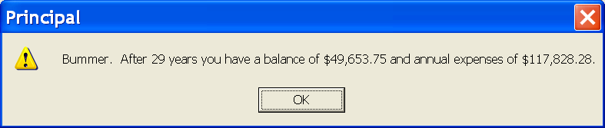

By changing the Growth% in the example above from 8% to 10%, the user won’t go broke. If the user still has principal after the number of years specified, then print out this:

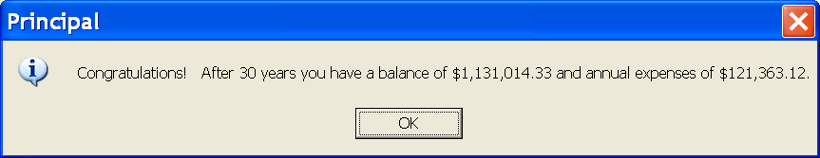

You find an executable version of this program (Problem8B.exe) and the images needed here: http://www.stonehill.edu/compsci/CS102/Programs/HomeworkEight.zip
SMACKDOWN (Add 1 point to final exam grade):

This program will allow you to flex your new found file processing skills to analyze the text of a file.

The program will:
- allow the user to select a file for analysis
- count the TOTAL number of words in the file
- allow the user to specify three different words
- count the number of times each user selected word appears in the file

I’ve provided two files for you to work with. The first file is called simple.txt. It contains the following text:

the rain in spain falls
mainly on the plain
in hartford haveford and
hampshire hurricanes hardly
ever happen

Here’s the output of the program, when it is run on simple.txt:
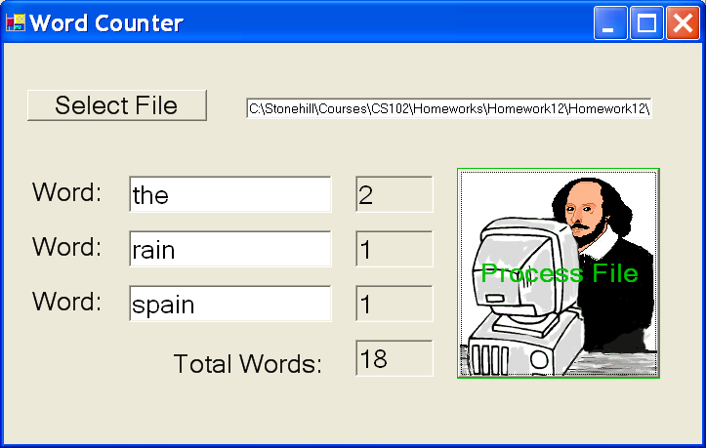

There are a total of 18 words in the file. The user typed in the words “the”, “rain”, and “spain” which appeared twice, once, and once respectively.

Here’s the output of the program when run on the file “muchadofull.txt”, the entire play of William Shakespeare’s Much Ado About Nothing. There are 22,424 words and “the” appears quiet often. William did not appear to acknowledge the Spanish in the play, and the play does seem rather dry ;).

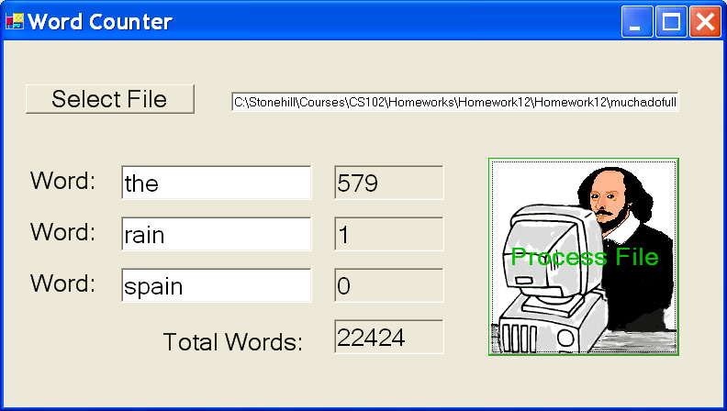

Here’s another run of the program against Shakespeare’s play using different search words:

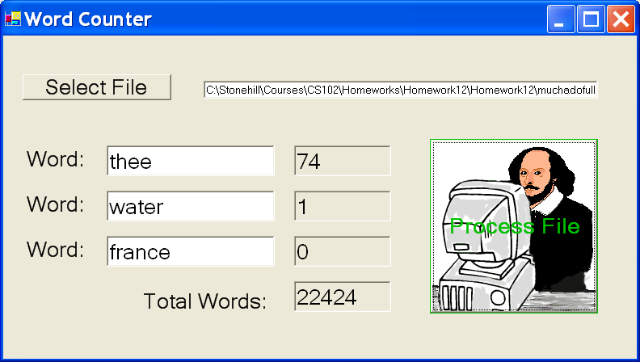

Thee seems pretty popular, but France is not, and it really does seem like a dry play!

PROCESSING THE WORDS IN A STRING
You already know how to read in a line of text from the keyboard (via Console.ReadLine()), a control (via Textbox.Text), and a file (via inFile.ReadLine()).
Let’s say that you have a variable, “line” that contains a line of text you just read in from a file. Line will look something like this:
“the rain in spain falls”
How do extract each word from this string?
Here’s a method that will help you:
' Precondition: line is a string containing some words separated by blanks
' position is the zero-based location of the word in the string
' position = 0 gets you the first word
' position = 1 gets you the second word, etc.
'
' Postcondition: returns the word in the string identified by position
' if position is too large, we return the empty string
'
' Example:
' line = "the rain in spain"
' getWord(line,0) returns "the"
' getWord(line,2) returns "in"
' getWord(line,4) returns ""
'
Function getWord(ByVal line As String, ByVal position As Integer) As String
...
End Function
I’ve written the method for you and included it in the zip file for the homework assignment. You just have to copy the function into the code portion of your visual program.
You can find an executable version of this program (LastProgram.exe), the code for the getWord() function here: http://www.stonehill.edu/compsci/CS102/Programs/HomeworkTwelve.zip
Submitting your Homework:

Place your homework on your private network share drive.

