Homework Eight

CS102 Windows Programming for the Non-Programmer
Fall 2007
Date Due: 11-09-2007

Problem A:

This is a Console Application.

Write a program that computes the cost of a long-distance call. The cost of the call was determined according to the following rate schedule:

- Any call started between 8 a.m. and 6 p.m. Monday through Friday is billed at the rate of $.40 per minute.
- Any call starting before 8 a.m. or after 6 p.m. Monday through Friday is charged at a rate of $.25 per minute.
- Any call started on a Saturday or Sunday is charged at a rate of $.15 per minute.

The input will consist of the day of the week, the time the call was started, and the length of the call in minutes. The output will be the cost of the call. The time is to be input in 24 hour notation, so the time 1:30 p.m. is input as:

1330

The day of the week will be read in as one of the following pairs of strings:

Mo Tu We Th Fr Sa Su

You should use the least one select statement for the problem.

Problem B:

Write a program that determines a user’s horoscope.

The user selects an astrological sign by clicking on a radio button next to the sign:


User clicked on Cancer’s radio button.

The user then clicks on the “Get My Horoscope” button.

An event handler for the button click determines which radio button was selected and generates a MessageBox containing the horoscope:

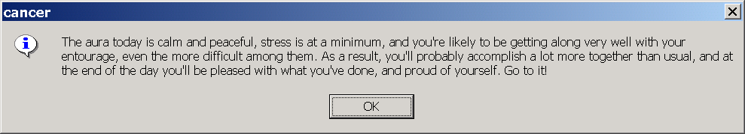

You find an executable version of this program (Program6A.exe) and the images needed here: http://www.stonehill.edu/compsci/CS102/Programs/HomeworkSix.zip
- Once you click on the above link, a window will appear. Press the “Open” button and you will see a list of files you can select from.
- Double click on the file “Program6A.exe” to turn the program.
- You can run it with different data. You might run the program to compare it to your own output.
- NOTE: this is a binary file. You will NOT be able to read the code in Visual Studio or any other editor.
SMACKDOWN (Optional):
[Complete this SMACKDOWN problem and add one point to your final exam grade.]
This is a Console Application.
Write a program which, given a date (month, day, year), will calculate the day of the week on which the given date fell.
For any date after March 1, 1600, this can be easily calculated with the following formula:
day = (r + [2.6m - .2] - 2c + d + [c/4.0] +[d/4.0] ) Mod 7
where
[x] denotes the greatest integer less than or equal to x.
c = first two digits of the year. (If the year is 1898, c = 18).
d = the last two digits of the year. (If the year is 1998, d = 98).
r = the day of the month (If the date is May 23, 1998, r = 23).
m = the month. March is considered month 1, April is 2, May is 3...February is month 12.
Note: For this calculation, March 1 is considered the first day of the year. Thus, March 1, 2001 is considered the first day of 2001 and consequently February 28, 2002 is the last day of 2001. Similarly, March 1, 1625 is the first day of 1625 and February 28, 1626 is the last day of 1625 etc.
Finally, if the value of the variable day is negative (The integer 0 denotes Sunday, 1 denotes Monday etc. (and it may be!), just add 7 to the result and you will have a value for day in the range 0..6 i.e. in the range Sunday..Saturday.
Examples:
January 5, 1987
m = 11 ( January)
c = 19
d = 86 ( January 1987 is considered the 11th month in 1986)
r = 5
July 4, 1776 :
m = 5 ( March(1) April(2) May(3) June(4) July(5))
c = 17
d = 76 (July is the 5th month of 1776)
r = 4
Your program should prompt the user for a date as in the following sample run. You may assume the date is a valid date.
Sample Run: (User input is red).
Month: 1 // This is January
Day: 17
Year: 1932
January 17, 1932 was on a Sunday
Run again? Y
Month: 7 // This is July
Day: 4
Year: 1776
July 4, 1776 was on a Thursday
Run Again? n
To download an executable version of the assignment click here
Submitting your Homework:

Place your homework on your private network share drive.

